Lesson 01: Going to Catechism

Why go to catechism?
My parents ______________________________________________________________________
My parents ______________________________________________________________________

Baptism
What is the name of the minister who baptized you? ________________________________________
1. Is this important information? _____ because ____________________________________________
________________________________________________________________________________
2. Why do grandparents like to be at the baptism of a grandchild? ______________________________
________________________________________________________________________________
________________________________________________________________________________
3. Why does baptism take place in the presence of the whole congregation (weddings don’t)? ________
________________________________________________________________________________
________________________________________________________________________________
________________________________________________________________________________
________________________________________________________________________________
________________________________________________________________________________

Baptism – an acknowledgement
________________________________________________________________________________
________________________________________________________________________________
________________________________________________________________________________

Baptism – a confession
________________________________________________________________________________
________________________________________________________________________________
________________________________________________________________________________

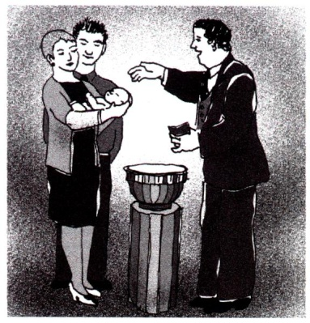
Baptism – a promise
____________________________________________________________
____________________________________________________________
____________________________________________________________
____________________________________________________________
____________________________________________________________
____________________________________________________________

Bible Study: Deuteronomy 6:1-9
1. Why did Israel receive the commandments, statutes and rules of the LORD?
Verse 1b: ________________________________________________________________________
________________________________________________________________________________
Verse 2a: ________________________________________________________________________
________________________________________________________________________________
2. Israel had to hear the commandments. What else? ________________________________________
3. What two things does this imply? _____________________________________________________
4. Where are the commandments of the Lord to be? _________________________________________
5. What must an Israelite do with the commandments in relation to children? _____________________
________________________________________________________________________________
6. When and where should the commandments be taught? ____________________________________
________________________________________________________________________________
7. Where did a copy of the law have to be kept symbolically? _________________________________
________________________________________________________________________________

Calling
I, ____________________________________________________, am ______________________
________________________________________________________________________________

Growing in faith
Catechism aims to prepare you to respond to your calling.
It will help you:
______________________________________________________________________
______________________________________________________________________
_____________________________________________________________________

Not neutral
Catechism is ___________________________. As you ______________________________________
________________________________________________________________________________
________________________________________________________________________________

You yourself a believer
The Lord’s Supper serves _____________________________________________________________
once you have indicated you __________________________________________________________

