Lesson 02: Review 01

Memory work
(If you memorized Hymn 64:1&2, you may write it out on the back of this sheet)

What is your only comfort in life and death?
A. That _________________________________
but _____________________________________________________________________________
to ______________________________________
He has _________________________________________________________________________
and _________________________________________________________________________
He _____________________________________________________________________________
that _________________________________________________________________________
____________________________________________________________________________
indeed,_______________________________________________________________________
Therefore, ______________________________________________________________________
_____________________________________________________________________________
_____________________________________________________________________________

Review Questions
1. (4) Why do your parents make you go to Catechism?
1. ______________________________________________________________________________
2. ______________________________________________________________________________
2. (3) What did your parents promise at your baptism?
________________________________________________________________________________
________________________________________________________________________________
________________________________________________________________________________
3. (3) Complete the following. Catechism will help you
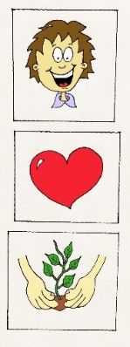
_________________________________________________________________________
________________________________________________________________________
_________________________________________________________________________
_________________________________________________________________________
_________________________________________________________________________
_________________________________________________________________________
_________________________________________________________________________

Space to write out Hymn 64
________________________________________________________________________________
________________________________________________________________________________
________________________________________________________________________________
________________________________________________________________________________
________________________________________________________________________________
________________________________________________________________________________
________________________________________________________________________________
________________________________________________________________________________
________________________________________________________________________________
________________________________________________________________________________
________________________________________________________________________________
________________________________________________________________________________
________________________________________________________________________________
________________________________________________________________________________
________________________________________________________________________________
________________________________________________________________________________
________________________________________________________________________________
________________________________________________________________________________
________________________________________________________________________________
________________________________________________________________________________
________________________________________________________________________________
________________________________________________________________________________
________________________________________________________________________________
________________________________________________________________________________
________________________________________________________________________________
________________________________________________________________________________
________________________________________________________________________________
________________________________________________________________________________
________________________________________________________________________________
________________________________________________________________________________
________________________________________________________________________________
________________________________________________________________________________
________________________________________________________________________________

