Lesson 03: Misery

The only way to know
The only way to truly know what our problem is as human beings _____________________________
________________________________________________________________________________
________________________________________________________________________________

Like a mirror
The law of God is _______________________________________________________________
You look in __________________ and ________________________________________________
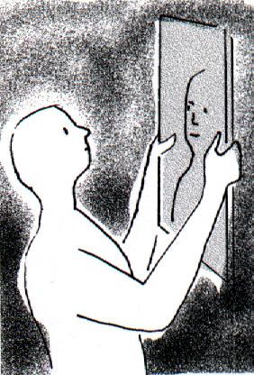
You look into __________________ and _________________
__________________________________________________
If you consider yourself ugly, you don’t enjoy looking in a mirror.
You’ll avoid it as much as you can.
You may even hate mirrors!
Because we are sinful ________________________________
It ________________________________________________
But ______________________________________________
__________________________________________________
We can go _________________________________________
__________________________________________________
We can go _______________________________________________________________________

Where on the scale are you?
Totally sinful Perfectly good
______________________________________________________________________________
0 1 2 3 4 5 6 7 8 9 10

Bible Study: Matthew 22:34-40
1. What sort of a person asked the question? _______________________________________________
________________________________________________________________________________
2. What question did he ask? ___________________________________________________________
________________________________________________________________________________
3. Summarize the law of God with just one word. ____________
4. Who should this be focussed on? ______________________________________________________
________________________________________________________________________________
5. Aren’t people allowed to love themselves? ______________ because _________________________
________________________________________________________________________________
6. What does “all the Law and the Prophets” refer to? _______________________________________
________________________________________________________________________________

Misery
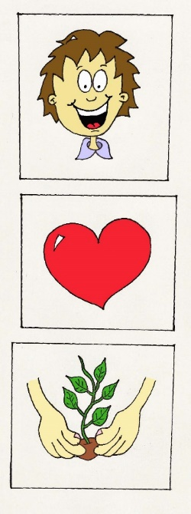

_______________________________________________________________

_______________________________________________________________

_______________________________________________________________

Our Real Misery
Our misery is not so much __________________________________________________________
________________________________________________________________________________
Our real misery is _________________________________________________________________

Where are we at?
In the Bible
Love is _________________________________________
Hatred is ____________________________________________
After the Fall into Sin ______________________________________________________________
________________________________________________________________________________
________________________________________________________________________________

Where on the scale should you put yourself?
Totally sinful Perfectly good
______________________________________________________________________________
0 1 2 3 4 5 6 7 8 9 10

