Lesson 4: How It Went Wrong

Man: a unique creature
Plants and animals were created _____________________________________________________
Man was created _________________________________________________________________
Reason: ______________________________________________________________________

Man’s position
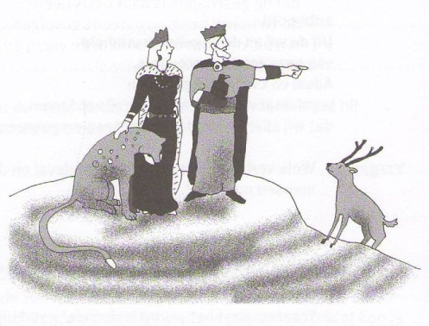
__________________________________________________
__________________________________________________

__________________________________________________
__________________________________________________

__________________________________________________
__________________________________________________

Not God’s fault
So: The origin of our fallen nature ____________________________________________________
For God _________________________________________________________________________

Bible Study: Genesis 3:1-13
1. What’s very wrong with the question the serpent asked? ___________________________________
________________________________________________________________________________
2. What do you think this question was trying to do? ________________________________________
________________________________________________________________________________
3. In her response, the woman is not completely truthful. What phrase in her answer is not correct?
(check back to Genesis 2:17) ________________________________________________________
4. Does the woman’s response make God’s prohibition sound better or worse? ___________________
5. The serpent tells two lies in response to the woman’s response. Which? _______________________
________________________________________________________________________________
________________________________________________________________________________
6. What should the man, the woman’s husband, have done? __________________________________
________________________________________________________________________________
7. Which three things make clear that things had now changed? _______________________________
________________________________________________________________________________
________________________________________________________________________________
________________________________________________________________________________

The Plunge into Sin (discussion)
1. What, at bottom, is the question the woman and the man faced?______________________________
________________________________________________________________________________
2. What, at bottom, is sin about? At bottom, sin is about ___________________________________
________________________________________________________________________________
________________________________________________________________________________

Not a myth
Many religions regard ________________________________________________________________
________________________________________________________________________________
________________________________________________________________________________
The Plunge into Sin was _______________________________________________________________
Adam and Eve ______________________________________________________________________
They were __________________________________________________________________________
The tree ___________________________________________________________________________
The snake __________________________________________________________________________

The disappointment of God
God had created us humans ____________________________________________________________
We were to _______________________ and thus __________________________________________
and ____________________________________________________
But we went and did __________________________________________________________________
and we __________________________________________________________________________
Small wonder ____________________________________________. That’s why He placed us ______
______________________________________________________________
At bottom, _________________________________________________________________________
And by nature we are _____________, wanting to be ____________________________________.
If we are left to ourselves, _____________________________________________________________
_______________________________________________________ (see Genesis 6:5).

Totally corrupt
We are so self-centred that of ourselves ___________________________________________________
________________________________________________________________________________
________________________________________________________________________________
And if God has changed you, you are, in reality, no longer totally corrupt,
but already have a small beginning of obedience!

