Lesson 02: Review 01

Memory work

What is your only comfort in life and death? (or write out Hymn 64 on the reverse of this sheet)
A. That _____________________________
________________________________________________________________________________
_________________________________________________________________
He has _________________________________________________________________________
____________________________________________________________________________
He _____________________________________________________________________________
____________________________________________________________________________
____________________________________________________________________________
___________________________________________________________________________
Therefore, ______________________________________________________________________
_____________________________________________________________________________
_____________________________________________________________________________

Review Questions
1. (4) Why do your parents make you go to Catechism?
1. ______________________________________________________________________________
2. ______________________________________________________________________________
2. (3) Complete the following. Catechism will help me
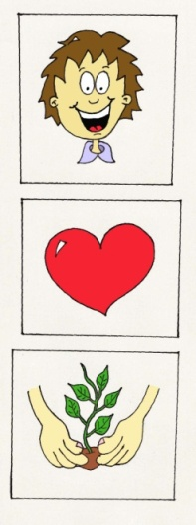
___________________________________________________________________
_______________________________________________________________________

_______________________________________________________________________
_______________________________________________________________________

_______________________________________________________________________
_______________________________________________________________________

3. (3) Is catechism neutral? ________ because _____________________________________________
________________________________________________________________________________
________________________________________________________________________________
________________________________________________________________________________

Hymn 64:
________________________________________________________________________________
________________________________________________________________________________
________________________________________________________________________________
________________________________________________________________________________
________________________________________________________________________________
________________________________________________________________________________
________________________________________________________________________________
________________________________________________________________________________
________________________________________________________________________________
________________________________________________________________________________
________________________________________________________________________________
________________________________________________________________________________
________________________________________________________________________________
________________________________________________________________________________
________________________________________________________________________________
________________________________________________________________________________
________________________________________________________________________________
________________________________________________________________________________
________________________________________________________________________________
________________________________________________________________________________
________________________________________________________________________________
________________________________________________________________________________
________________________________________________________________________________
________________________________________________________________________________
________________________________________________________________________________
________________________________________________________________________________
________________________________________________________________________________
________________________________________________________________________________
________________________________________________________________________________
________________________________________________________________________________
________________________________________________________________________________
________________________________________________________________________________
________________________________________________________________________________

