Lesson 03: Misery

The only way to know
The only way to truly know what our problem is as human beings _____________________________
________________________________________________________________________________
________________________________________________________________________________

Like a mirror
The law of God is _______________________________________________________________
You look in __________________ and ________________________________________________
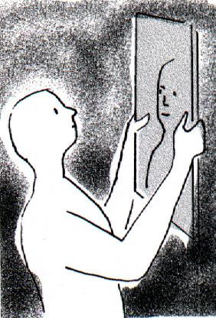
You look into __________________ and _________________
__________________________________________________
If you consider yourself ugly, you don’t enjoy looking in a mirror.
You’ll avoid it as much as you can.
You may even hate mirrors!
Because we are sinful ________________________________
It ________________________________________________
But ______________________________________________
__________________________________________________
We can go _________________________________________
__________________________________________________
We can go _______________________________________________________________________

Where on the scale are you?
Totally sinful Perfectly good
______________________________________________________________________________
0 1 2 3 4 5 6 7 8 9 10

Bible Study: Ephesians 2:1-3
1. What were the first readers of the letter to the Ephesians? __________________________________
________________________________________________________________________________
2. When were they this? _______________________________________________________________
________________________________________________________________________________
3. This is not just true for the first readers. For whom is this also true? __________________________
4. What are we all by nature? ___________________________________________________________

Our Real Misery
Our misery is not so much __________________________________________________________
________________________________________________________________________________
Our real misery is our ______________________________________________________________

Where are we at?
________________________________________________________________________________
________________________________________________________________________________
________________________________________________________________________________
________________________________________________________________________________
________________________________________________________________________________
________________________________________________________________________________

Where on the scale should you put yourself?
Totally sinful Perfectly good
______________________________________________________________________________
0 1 2 3 4 5 6 7 8 9 10

How good, how bad?
Pelagianism: ________________________________________________________________________
________________________________________________________________________________
Daoism: ___________________________________________________________________________
________________________________________________________________________________
Arminianism: _______________________________________________________________________
________________________________________________________________________________
Calvinism: _________________________________________________________________________
________________________________________________________________________________

Canons of Dort III/IV.1-3
1. What was the effect of the Fall? _______________________________________________________
________________________________________________________________________________
________________________________________________________________________________
2. How does corruption spread? _________________________________________________________
________________________________________________________________________________
3. How does the confession describe man’s ability to do good (in brief)? ________________________
________________________________________________________________________________

