Lesson 4: How It Went Wrong

Man: a unique creature
Plants and animals were created ________________________________________________________
Man was created ____________________________________________________________________
Reason: _________________________________________________________________________

Man’s position
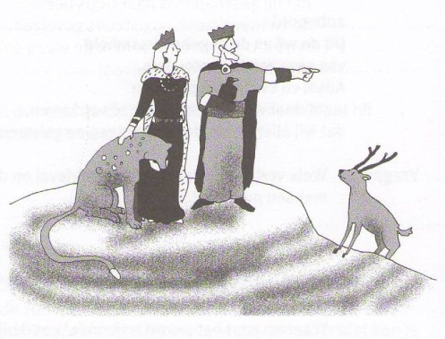
__________________________________________________
__________________________________________________

__________________________________________________
__________________________________________________

__________________________________________________
__________________________________________________

Man: loving and loyal
There are more sides to being the image of God. Another is that we are to be as God is.
God is _____________________________________________________________________________
We are to be _______________________________________________________________________
________________________________________________________________________________
________________________________________________________________________________

Not God’s fault
________________________________________________________________________________
________________________________________________________________________________
________________________________________________________________________________

Bible Study: Genesis 3:1-13
1. What’s very wrong with the question the serpent asked? ___________________________________
_______________________________________________________________________________
2. What do you think this question was trying to do? _______________________________________
_______________________________________________________________________________
3. In her response, the woman is not completely truthful. What phrase in her answer is not correct?
_______________________________________________________________________________
4. Does the woman’s response make God’s prohibition sound better or worse? ___________________
5. The serpent tells two lies in response to the woman’s response. Which? ______________________
_______________________________________________________________________________
________________________________________________________________________________
6. What should the man have done? ______________________________________________________
________________________________________________________________________________
7. Which three things make clear that things had now changed? _______________________________
________________________________________________________________________________
________________________________________________________________________________
________________________________________________________________________________

The Plunge into Sin (discussion)
1. What, at bottom, is the question the woman and the man faced? _____________________________
________________________________________________________________________________
2. What, at bottom, is sin about? ________________________________________________________
________________________________________________________________________________
________________________________________________________________________________
3. What was the effect of the plunge into sin? ______________________________________________
________________________________________________________________________________

The Tree of Knowledge of Good and Evil
The tree stands symbol for _____________________________________________________________
________________________________________________________________________________
Eating of that tree is symbolic for _______________________________________________________
________________________________________________________________________________
________________________________________________________________________________

The disappointment of God
God had created us humans ____________________________________________________________
We were to _______________________ and thus __________________________________________
and ____________________________________________________
But we went and did __________________________________________________________________
________________________________________________________________________________
________________________________________________________________________________
That’s why He placed us ______________________________________________________________
At bottom, _________________________________________________________________________
And by nature we are _____________, wanting to be ____________________________________.
If we are left to ourselves, _____________________________________________________________
_______________________________________________________ (see Genesis 6:5).

