Lesson 05: Review 04

Memory work

6. Q. Did God, then, create man so wicked and perverse?
A. No, __________________________________
God ____________________________________________________________________________

7. Q. From where, then, did man’s depraved nature come?
From ______________________________________________________________________________
________________________________________________________________________________
for _____________________________________________________________________________
that ___________________________________________________________________________.

8. Q. But are we so corrupt that we are totally unable to do any good and inclined to all evil?
______, unless ___________________________________________________________________
________________________________________________________________________________

Review questions
1.(2) What makes humans unique as creatures? ____________________________________________
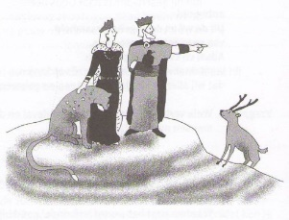
2.(3) Fill in the scheme: God is ___________________
↓
Man is ____________________
↓
Creation is ___________________
3.(2) Is the Fall into Sin a myth? Yes / No
4.(3) What, at bottom, is God’s curse? ____________________________________________________
________________________________________________________________________________
________________________________________________________________________________
________________________________________________________________________________

