Lesson 05: God Keeps His Word

The Plunge into Sin
At the _________________________________________________ (the serpent lied to the woman)
in __________________________________ (the man and the woman knew what they were doing)
humanity ________________________________________________________________________
The man and the woman ___________________________________________________________
________________________________________________________________________________
God, however, ____________________________________________________________________

Bible Study: Genesis 3:14-19
1. What curse does the serpent get? ______________________________________________________
________________________________________________________________________________
________________________________________________________________________________
2. What will the relationship between snakes and people be? _________________________________
3. What is this a symbol of? _____________________________________________________
________________________________________________________________________________
4. What curse does the woman get? _____________________________________________________
________________________________________________________________________________
5. What will the relationship between men and women be? ___________________________________
________________________________________________________________________________
6. What curse does the man get? ________________________________________________________
________________________________________________________________________________
7. What punishment does humanity receive? _______________________________________________
________________________________________________________________________________

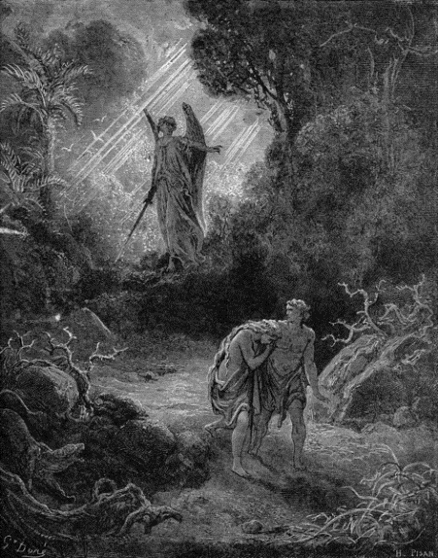
GO!
Man no longer _________________________________________
___________________________________________________
Life is only ___________________________________________
___________________________________________________
Hence _______________________________________________
___________________________________________________
God did ______________________________________________
___________________________________________________
___________________________________________________

The Righteousness of God
God had clearly forbidden man _____________________________________________________
________________________________________________________________________________
God had indicated _________________________________________________________________
________________________________________________________________________________
The man and the woman ___________________________________________________________
they could be _________________________________________________________________
Thus God was ___________________________________________________________________
The LORD God is ________________________________________________________________
He does what is _______________________________________________________________

Bible Study discussion: Genesis 6:1-13
Was God’s punishment deserved? ________because ________________________________________
________________________________________________________________________________
Was God’s punishment fair? ____________because ________________________________________
________________________________________________________________________________

Just punishments
Sin Punishment
_____________________________________ _________________________________________
_____________________________________ _________________________________________
_____________________________________ _________________________________________

Our sinfulness
1. a. What do we mean by “original sin”? _________________________________________________
b. Is this the same or different for everyone? ____________________________________________
2. a. What do we mean by “actual sins”? __________________________________________________
b. Is this the same or different for everyone? ____________________________________________
_____________________________________________________________________________
3. What is the relationship between original sin and actual sins? _______________________________
4. What does Galatians 3:10 mean for all people? ___________________________________________
________________________________________________________________________________

Mercy and Justice
God is _________ in His _____________ and ____________________ in His ________________.
His justice is: ____________________________________________________________________
His mercy is: ____________________________________________________________________
________________________________________________________________________________

