Lesson 6: Atonement ... Not Simple!

Atonement
The word atonement has been made up by ________________________________________________
________________________________________________________________________________
It is made up of the two words: ________________________________________________________
____________ invented it to express _____________________________________________________
________________________________________________________________________________
________________________________________________________________________________
God and man become at one with each other.
@ + 1 = ATONE

Two things are needed
For atonement to take place, for a person to live eternally with God, two things are needed.
1. ________________________________________________________________________________
________________________________________________________________________________
________________________________________________________________________________
2. ________________________________________________________________________________
________________________________________________________________________________
________________________________________________________________________________
________________________________________________________________________________
I.e. get rid of the bad and ensure there is good

Can we save ourselves?
There’s a bit of logic in play here, in Lord’s Day 5a.
1. _____________________________________________________________________________
2. ______________________________________________________________________________
THEREFORE, ___________________________________________________________________
And
1. _____________________________________________________________________________
2. ______________________________________________________________________________
THEREFORE, ___________________________________________________________________
Conclusion
a. ______________________________________________________________________________
________________________________________________________________________________
b. ______________________________________________________________________________
________________________________________________________________________________

Atonement by another
In the Old Testament: When someone had sinned, a sin offering had to be brought.
And once a year, the Day of Atonement would be celebrated, to atone for all the sins of Israel.
In the Old Testament _________________________________________________________________
________________________________________________________________________________
________________________________________________________________________________
________________________________________________________________________________

Bible Study: Leviticus 4:27-31
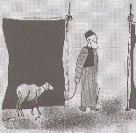
Note: to sin “unintentionally” means to sin out of weakness.
1. What animal is to be sacrificed for an unintentional sin? ___________________________________
________________________________________________________________________________
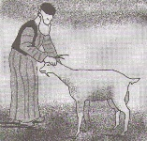
2. What is symbolized by the animal being “without blemish”? _______________________________
________________________________________________________________________________
3. What is the meaning of the laying on of hands? __________________________________________
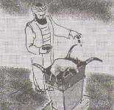
________________________________________________________________________________
4. What was poured out at the base of the altar? ______________________
5. What was burned on the altar? ________________________________________________________
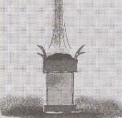
Any idea why? ___________________________________________________________________
________________________________________________________________________________
________________________________________________________________________________

Good enough?
The sacrifice of an animal _____________________________________________________________
________________________________________________________________________________
________________________________________________________________________________
For note:
1. _____________________________________________________________________________
2. _____________________________________________________________________________

A Saviour is Needed
The Old Testament ________________________________________________________________
________________________________________________________________________________
________________________________________________________________________________
Humanity must expect _____________________________________________________________
________________________________________________________________________________
Scripture tells the story of the snake crusher.

