Lesson 07: God Sends The True Mediator

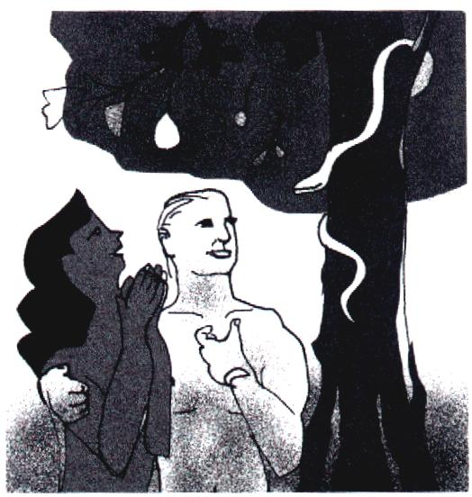
What we have seen so far
Through the Plunge into Sin __________________________________
______________________________________________________
God is ____________________________________________________
Atonement is ______________________________________________
_______________________________________________________
Neither ___________________________________________________
_______________________________________________________

What makes a good mediator?
Man sinned so ______________________________________________________________________
Therefore, the mediator must be _____________________________________________________
Man owes __________________________________________________________________________
Therefore, the mediator must be ______________________________________________________
The penalty _________________________________________________________________________
Therefore, the mediator must have ____________________________________________________
________________________________________________________________________________
________________________________________________________________________________

Given by God
God ____________________________________________________________________________
This is proof of __________________________________________________________________

What Jesus did
• ________________________________________________________________________________
________________________________________________________________________________
• ________________________________________________________________________________
________________________________________________________________________________
• ________________________________________________________________________________
________________________________________________________________________________
• ________________________________________________________________________________
________________________________________________________________________________

Bible Study: Romans 5:6-11
1. What were we (2 things) when Christ died for us? ____________________ and ________________
2. What did God show in Christ’s death? _______________________________________
3. What makes this so special? __________________________________________________________
________________________________________________________________________________
4. How have we been reconciled to God? _________________________________________________
5. How are we saved from God’s wrath? __________________________________________________
6. What else flows from the work of Christ? _______________________________________________

Delivered
It is _________________________________________________that true atonement for sin was made.
________________________________________________________________________________
________________________________________________________________________________
________________________________________________________________________________

Mediator
The position of Jesus Christ is that ______________________________________________________
________________________________________________________________________________
________________________________________________________________________________

True Atonement is
- that ______________________________________________________________________________
________________________________________________________________________________
- that ______________________________________________________________________________
________________________________________________________________________________
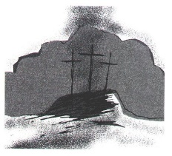
________________________________________________________________________________

What saves us?
Praying lots? Going to church often? Paying much money to church and charity? Living a good and holy life? NO! They’re important, but they don’t save us.
What saves us is
_____________________________________________________
_____________________________________________________

