Lesson 05: Review 04

Memory work

6. Q. Did God, then, create man so wicked and perverse?
A. ____, on the _________________________
God ____________________________________________________________________________
that is,_______________________________________________________________________
so that he _______________________________________________________________________
_____________________________________________________________________________
_____________________________________________________________________________

7. Q. From where, then, did man’s depraved nature come?
From ______________________________________________________________________________
________________________________________________________________________________
for _____________________________________________________________________________
that ___________________________________________________________________________.

8. Q. But are we so corrupt that we are totally unable to do any good and inclined to all evil?
_____, unless ____________________________________________________________________
________________________________________________________________________________

Review questions
1.(2) What makes man a unique creature? ________________________________________________
2.(2) Answer 6 above describes what being God’s image is. Last week we also paid attention to an aspect of being God’s image that is not mentioned in answer 6. Complete the following sentences which relate to that aspect.
God is ________________ and _______________.
Man, as God’s image, is to be _______________ and ___________________ towards God, fellow man, and all creation.
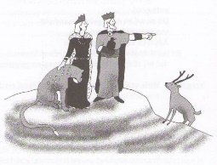
3.(3) Fill in the scheme: God is ___________________
↓
Man is ____________________
↓
Creation is ___________________
4. (3) What, at bottom (very basically), is God’s curse? ______________________________________
________________________________________________________________________________
________________________________________________________________________________
________________________________________________________________________________

