Lesson 05: God Keeps His Word

The Plunge into Sin
At the _________________________________________________ (the serpent lied to the woman)
in __________________________________ (the man and the woman knew what they were doing)
humanity ________________________________________________________________________
The man and the woman ___________________________________________________________
________________________________________________________________________________
God, however, ____________________________________________________________________

Bible Study: Genesis 3:14-19
1. What curse is given to the serpent? ____________________________________________________
________________________________________________________________________________
________________________________________________________________________________
2. What will the relationship between snakes and people be? _________________________________
3. What does this stand symbol for? _____________________________________________________
________________________________________________________________________________
4. What curse is given to the woman? ____________________________________________________
________________________________________________________________________________
5. What will the relationship between men and women be? ___________________________________
________________________________________________________________________________
6. What curse is given to the man? ______________________________________________________
________________________________________________________________________________
7. What curse does mankind receive? ____________________________________________________
________________________________________________________________________________

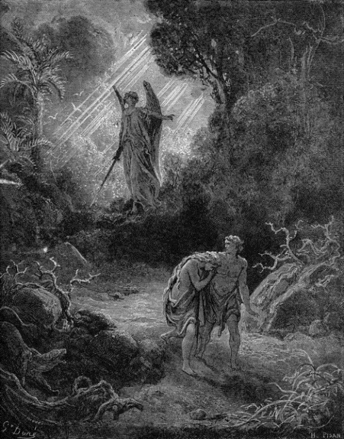
GO!
Man no longer _________________________________________
___________________________________________________
Life is only ___________________________________________
___________________________________________________
Hence _______________________________________________
___________________________________________________
God did allow man durable clothes made of animal skins.

The Righteousness of God
God had clearly forbidden man to eat. God had indicated the penalty on eating would be death. The man and the woman sinned deliberately, they could be held accountable.
Thus, ______________________________________________________________________________
________________________________________________________________________________
________________________________________________________________________________

Our Sinfulness
1. a. What do we mean by “original sin”? _________________________________________________
b. Is this the same or different for everyone? ____________________________________________
2. a. What do we mean by “actual sins”? _________________________________________________
b. Is this the same or different for everyone? ____________________________________________
________________________________________________________________________________
3. What is the relationship between original sin and actual sins? _______________________________
4. What does Galatians 3:10 imply for all people? _________________________________________
________________________________________________________________________________

Mercy and Justice (2 slides)
God’s mercy and justice _______________________________________________________________
Those who contrast them see ___________________________________________________________
Mercy = ________________________________________________________________________
Justice = ________________________________________________________________________
But God is _________________________________________________________________________
The two go together.
His justice is: ____________________________________________________________________
His mercy is: ____________________________________________________________________

The Severity of the Punishment
God created this world and God created us.
God _______________________________________________________________________________
________________________________________________________________________________
________________________________________________________________________________
We _______________________________________________________________________________
It would be _________________________________________________________________________
Eternal death means _________________________________________________________________
________________________________________________________________________________
That’s a ____________________________________________________________________________

