Lesson 09: Review 08

Memory work
39. Q. Does it have a special meaning that Christ was crucified and did not die in a different way?
__________
__________________________________________
_______________________________________________________________________
________________________________________________________________________
43. What further benefit do we receive from Christ’s sacrifice and death on the cross?
Through ________________________________________________________________
_____________________________________________________________________________
So that _________________________________________________________________________
_____________________________________________________________________________
________________________________________________________________________________
_____________________________________________________________________________

Review questions
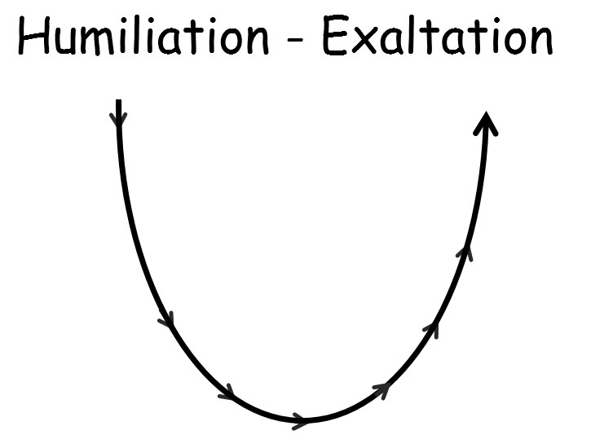
1.(8) What are the stages of the humiliation and exaltation of Christ?

2.(1) Could Christ’s death pay for the sins of all people? _______________________
3.(1) Did Christ’s death pay for the sins of all people? __________________________

