Lesson 13: The Bible (1)

Pentecost
After the Paradise-Flood era and the Babel experience, ______________________________________
________________________________________________________________________________
________________________________________________________________________________
With Pentecost ______________________________________________________________________
God’s Word is now _______________________________________________________________

From spoken to written
As special revelation took place, ________________________________________________________
Over ________________ the Bible grew to be what it is now.
As we live after Christ and the apostles, in the last days, _____________________________________
________________________________________________________________________________
Never have human beings _____________________________________________________________
________________________________________________________________________________
________________________________________________________________________________
________________________________________________________________________________

Bible Study: Various
1. Look up 2 Timothy 3:16. What is Holy Scripture said to be? ________________________________
2. What is Scripture useful for? _________________________________________________________
________________________________________________________________________________
3. Look up 2 Peter 1:16. What does Peter say here about the message apostles bring? ______________
________________________________________________________________________________
4. Read verse 20-21. What made prophets speak? __________________________________________
5. Look up 2 Peter 3:16. Would Peter have considered the writings of Paul part of the Bible? ________

Organic Inspiration
God did not use _____________________________________________________________________
________________________________________________________________________________
________________________________________________________________________________
God used people _____________________________________________________________________
________________________________________________________________________________
________________________________________________________________________________
________________________________________________________________________________
________________________________________________________________________________
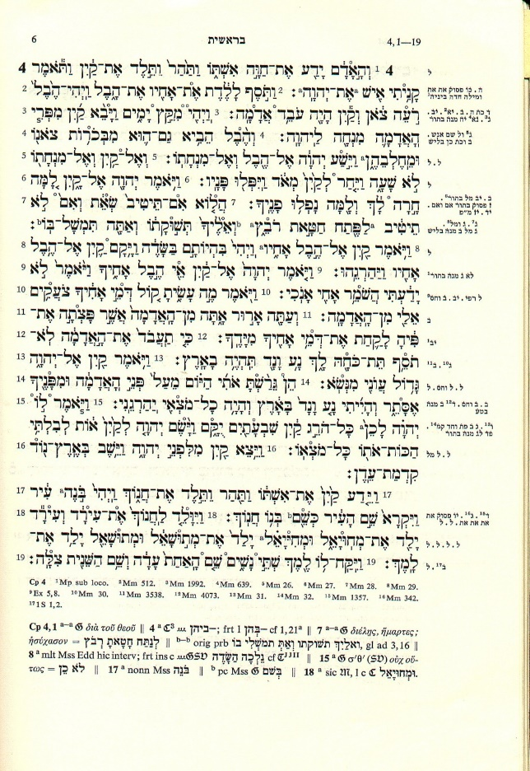

The Bible is old and accurate
There is no reason to doubt the age and accuracy of the Bible.
For the Old Testament:
___________________________________________
___________________________________________
___________________________________________
___________________________________________
For the New Testament:
___________________________________________
___________________________________________
___________________________________________
___________________________________________
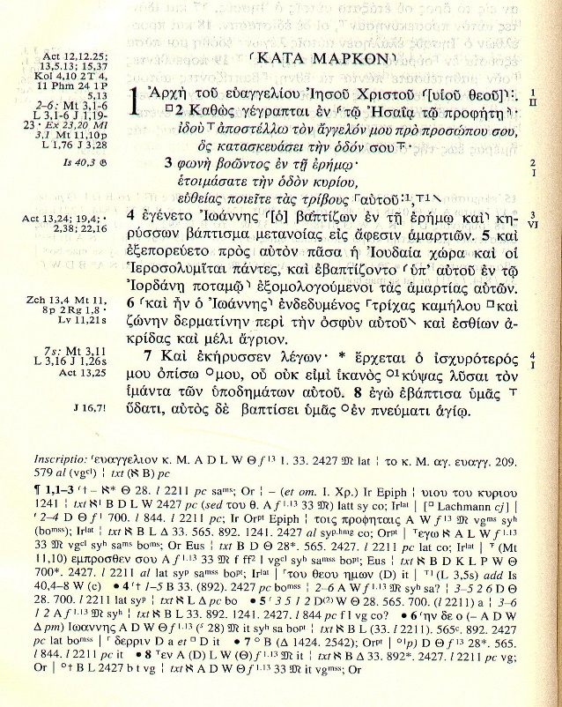
The Books of the Bible
___________________________________________
The Bible is actually _____________________________
The __________________________________________
___________________________________________
___________________________________________
Books belong to the Bible are said to be _____________

Apocrypha
There have been attempts _________________________
___________________________________________
The _____________________________ considers these
books biblical.
They call these the Deuterocanonical books, the second canon.
We call them _______________________________________________________________________
There are various reasons to doubt this books:
________________________________________________________________________________
________________________________________________________________________________
________________________________________________________________________________

