Lesson 15: Caring for Creation

Psalm 8 and Leviticus 25:1-7
1. What does it mean that we have been created “a little lower than God” (footnote)?
________________________________________________________________________________
2. Given Psalm 8:6, may we do with creation as we see fit?
________________________________________________________________________________
3. Why does “land” need “rest”?
________________________________________________________________________________
4. Should we still keep a sabbath year today? (We do have things called sabbaticals.)
________________________________________________________________________________

Christians and the Environment
Humans were made __________________________________________________________________
Among others it means that ____________________________________________________________
Humanity is the ___________________ of _______________________________________.
We need to treat _____________________________________________________________________
________________________________________________________________________________

Stewards
As stewards humans are to
- ___________________________________________ what God has made
e.g. __________________________________________________________________________
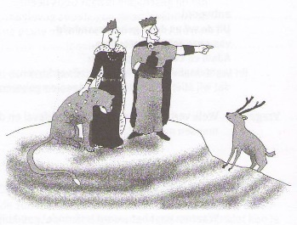
- _________________________________________ what God has made
e.g. _____________________________________________________
- _________________________________________ what God has made
e.g. _____________________________________________________

Still valid
__________________ is known as ___________________________________________________
__________________ is known as ___________________________________________________
Some Christians say: _________________________________________________________________
________________________________________________________________________________
However, __________________________________________________________________________
________________________________________________________________________________
The _________________ mandate has been _____________ to the _____________________ mandate.

The environmental movement
The environmental movement tends to be composed of ________________________________ and
__________________________________
As Christians we will have issues with
________________________________________________________________________________
________________________________________________________________________________
But _______________________________________________________________________________
________________________________________________________________________________

Three views of creation
________________________________________________________________________________
Creation exists ___________________________________________________________________
Man is _________________________________________________________________________
________________________________________________________________________________
Creation exists ___________________________________________________________________
Man is _________________________________________________________________________
________________________________________________________________________________
Creation exists ___________________________________________________________________
Man is _________________________________________________________________________

Whom do you trust?
Scientists dispute and debate what is happening today, and especially, who caused it.
___________________________________ when it comes to using data that extrapolate.
But we should not be ____________________________________.
Climate change is ___________________________________________ and _____________________
________________________________________________________________________________

Space for further notes
________________________________________________________________________________
________________________________________________________________________________
________________________________________________________________________________
________________________________________________________________________________
________________________________________________________________________________
________________________________________________________________________________
________________________________________________________________________________
________________________________________________________________________________

