Lesson 16: Review 15

Memory work

24. Q. How are these articles divided?
Into ___________________________________________________________________________
________________________________________________________________________________
________________________________________________________________________________
________________________________________________________________________________

25. Q. Since there is only one God, why do you speak of three persons, Father, Son, and Holy Spirit?
Because _________________________________________________________________________
That ___________________________________________________________________________
________________________________________________________________________________

Review
1.(2) Complete the following sentence: To confess your ___________ is to say __________________ what ______________________ says.
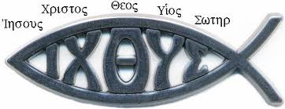
2.(2) The fish-symbol is in fact a brief confession. What is being confessed?
_______________________________________________________
_______________________________________________________
________________________________________________________________________________
________________________________________________________________________________
________________________________________________________________________________
________________________________________________________________________________
3.(2) The structure of our creeds is determined by something Christ commanded the church to do. What was that command?
________________________________________________________________________________
________________________________________________________________________________
4.(2) True or false: the twelve apostles each wrote an article of the Apostles’ Creed. _______________
5.(2) Do Christians have three gods or one? ______________________

