Lesson 17: Call Him Jesus

Memory work
Instead of the texts below, you may also memorize the two songs on the back of this sheet.

28. Q. What does it benefit us to know that God has created all things and still upholds them by His providence?
A. We can be
patient in adversity,
thankful in prosperity,
and with a view to the future
we can have a firm confidence in our faithful God and Father
that no creature shall separate us from His love.
For all creatures are so completely in His hand
that without His will they cannot so much as move.

29. Q. Why is the Son of God called Jesus, that is, Saviour?
A. Because He saves us from all our sins,
and because salvation is not to be sought or found in anyone else.

Homework
Find out via a Bible or the internet (BibleGateway.com, Wikipedia) what the following names mean.
1.(1) Judah. __________________________________________
2.(1) Joseph. __________________________________________
3.(1) Benjamin. __________________________________________
4.(1) Jeruh-Baal. __________________________________________
What was his real name? ______________________________
5.(1) Elisha. __________________________________________
6.(1) Daniel. __________________________________________
7.(1) Peter. ____________________Cephas. ________________________
8.(1) Sometimes God gave a person a new name. Jacob, which means ______________________,
became Israel, which means ____________________________.
9. What does your name mean? _________________________________________________________
________________________________________________________________________________
________________________________________________________________________________
10.(1) Should we today pay attention to the meaning of a name? ____________________________
11.(1) Why is Jesus greater than Joshua? __________________________________________________
________________________________________________________________________________
________________________________________________________________________________
________________________________________________________________________________
Memorize the following song instead of q&a 28 (to the melody of Psalm 42)

We’ll be patient in our suffering
When we face adversity
With full trust about the future
Thankful in prosperity.
We will always know the love
Of our faithful God above.
In his hand is all creation
Subject to his good direction.

Memorize the following song instead of q&a 29

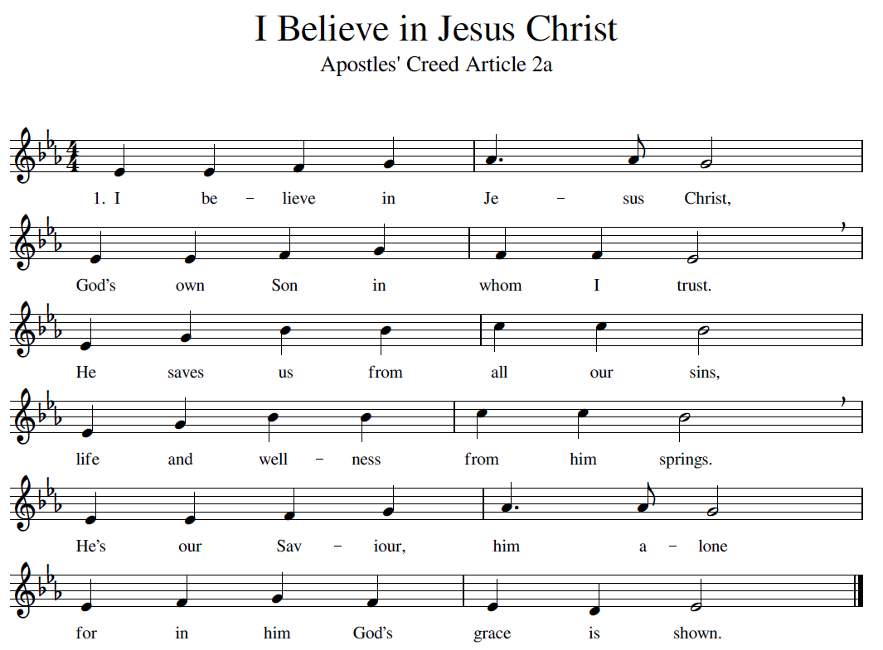

(For the melody: https://www.youtube.com/watch?v=D9dVNBgQX7Q or search Youtube for “Redhead Ajalon” – the song you need is a version of Psalm 51: “God, be merciful to me”).

