Lesson 18: Messiah. Christ. Anointed

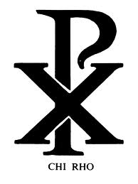
A symbol and three words
This is the Chi-Rho symbol. It combines the first two letters of the Greek word __________________
Hebrew: ___________________________________________
Greek: _____________________________________________
English: ____________________________________________

Anointed
Text | Anointer | Anointee(s) | Position
1 Kings 19:16b
Exodus 30:30
1 Samuel 10:1

The reasons for anointing
A person was anointed for two reasons. (Remember the words at 1 and 2, they are VERY important)
1. ____________________________
The anointing made clear that this person _________________________________________________
________________________________________________________________________________
________________________________________________________________________________
________________________________________________________________________________
2. ____________________________
The anointing made clear that this person _________________________________________________
________________________________________________________________________________
________________________________________________________________________________
________________________________________________________________________________

What were their tasks?
For each office, name three people who held that office
Prophet: _______________________________________________________________________
Priest: _________________________________________________________________________
King: ___________________________________________________________________________
Their tasks were:
Prophet: _______________________________________________________________________
Priest: _________________________________________________________________________
_________________________________________________________________________
King: ___________________________________________________________________________

Bible Study: Matthew 3:16-17
1. When exactly did Jesus receive His anointing? ___________________________________________
2. What was the baptism about (Matthew 3:11)? ____________________________________________
________________________________________________________________________________
3. Who descended upon the Jesus? __________________________________________
4. Who spoke from heaven? ___________________________________________________
Anointing is about authorization and qualification.
5. Wherein lies the authorization of Jesus as the Christ of God? ________________________________
________________________________________________________________________________
6. Wherein lies the qualification of Jesus as the Christ of God? ________________________________
________________________________________________________________________________

Jesus’ three-fold office
Jesus is the _______________, the _____________________________________________________
He is to God’s people _________________________________________________________________
And not just ________________________________________________________________________
He is the _____________ prophet, the ______________ high priest, and the ________________ king.

What Jesus does as
Prophet | Priest | King
Proclaim God’s word to the people. | Bring God and His people closer to each other through sacrifice and prayer. | To protect and rule over God’s people.
Some examples
__________________________  __________________________  __________________________ | __________________________  __________________________  __________________________ | __________________________  __________________________  __________________________

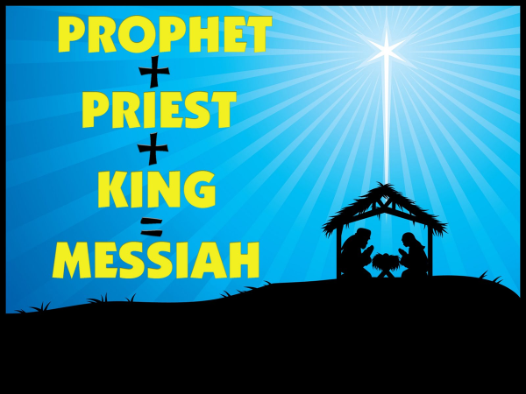

As what did Jesus do/say it?
Indicate which office goes with the statement.
 | Prophet | Priest | King
1. Die on the cross
2. Jesus prays that Peter might be kept safe from Satan.
3. Jesus said “What I teach I have received from Him who sent Me.”
4. Jesus is with us until the end of the world.
5. Jesus is the Good Shepherd who lays down His life for the sheep.
6. The Lord Jesus instructs the people travelling to Emmaus
7. Jesus said: “I tell you, if you call your brother a fool, you deserve to go to hell.”
8. Jesus praying for the unity of the church.
9. All authority in heaven and on earth belongs to Jesus.

What Jesus does for you
As prophet
He gives you the _______________ in the form of the ________________, and sends __________
__________ into your heart to make you understand ___________________.
As priest
He has paid ___________________ for your __________ and ___________ for you to the Father
to accept you __________________________________
As king
He ________________ your life, placing you in _________________________ where you will be
protected and taken care of.

