Lesson 18: Messiah. Christ. Anointed.

Memory work
You may also memorize verses 3-5 of the song on the other side of this sheet.

31. Q. Why is He called Christ, that is, Anointed?
A. Because He has been ordained by God the Father,
and anointed with the Holy Spirit,
to be
our chief Prophet and Teacher,
our only High Priest,
and our eternal King.

32. Q. Why are you called a Christian?
A. Because I am a member of Christ by faith and thus share in His anointing,
so that I may
as prophet confess His Name,
as priest present myself a living sacrifice of thankfulness to Him,
and as king fight against sin and the devil in this life,
and hereafter reign with Him eternally.

Homework
1.(2) In what ways (more than one!) does the Lord Jesus exceed all other prophets, priests, and kings?
________________________________________________________________________________
________________________________________________________________________________
________________________________________________________________________________
________________________________________________________________________________
________________________________________________________________________________
2.(6) Look up Hebrews 1:1-4.
Which words make clear Jesus is a prophet? _______________________________________________
________________________________________________________________________________
________________________________________________________________________________
Which words make clear Jesus is a priest? ________________________________________________
________________________________________________________________________________
________________________________________________________________________________
Which words make clear Jesus is a king? _________________________________________________
________________________________________________________________________________
________________________________________________________________________________
3.(2) Usually people in the Old Testament only held one office. One well-known person had two: he was both king and priest (Hebrews 7). Who was that? _________________________________

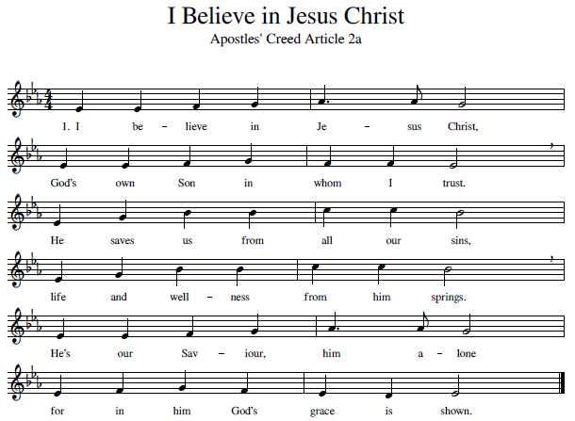
Memorize the stanzas 3, 4 & 5 for next time.

3. He is also called “the Christ”  for he is our great High Priest.  He died on the cursed tree  to redeem and set us free.  Now for us he intercedes  with the Father for our needs. | 4. Christ is our eternal King  who rules over everything.  By his Spirit and his Word  he directs us as our Lord.  Our redemption is secure.  He preserves us evermore.
5. Christ our Prophet does reveal
God’s own counsel and his will.
He’s the one from whom we learn
what his saving death did earn.
Jesus Christ, the Son of God!
We will praise his Name abroad.

