Lesson 17: Call Him Jesus

Memory work (you may also learn the 2 stanzas of the hymn on the back of this sheet)

29. Q. Why is the Son of God called Jesus, that is, Saviour?
A. Because He saves us from all our sins,
and because salvation is not to be sought or found in anyone else.

30. Q. Do those who seek their salvation or well-being in saints, in themselves, or anywhere else, also believe in the only Saviour Jesus?
A. No.
Though they boast of Him in words,
they in fact deny the only Saviour Jesus.
For one of two things must be true:
either Jesus is not a complete Saviour,
or those who by true faith accept this Saviour
must find in Him all that is necessary for their salvation.

Homework
What do the following names (use Wikipedia or Biblegateway to find out).
1. (1) Jeruh-Baal. __________________________________________
What was his real name? ______________________________
2. (1) Elisha. __________________________________________
3. (1) Daniel. __________________________________________
4. (1) Peter. __________________________________________
5. (1) Cephas. __________________________________________
6. (1) Sometimes God gave a person a new name. Jacob, which means ______________________
became Israel, which means ____________________________.
7.(1) What does your name mean? _____________________________________________
8.(2) Why is Jesus greater than Joshua? __________________________________________________
________________________________________________________________________________
________________________________________________________________________________
9.(1) People are baptized in the church, in many cultures this is when they get their name. Should a church refuse to baptize people with the name Jesus or Satan?
_______ because _________________________________________________________________
________________________________________________________________________________
________________________________________________________________________________

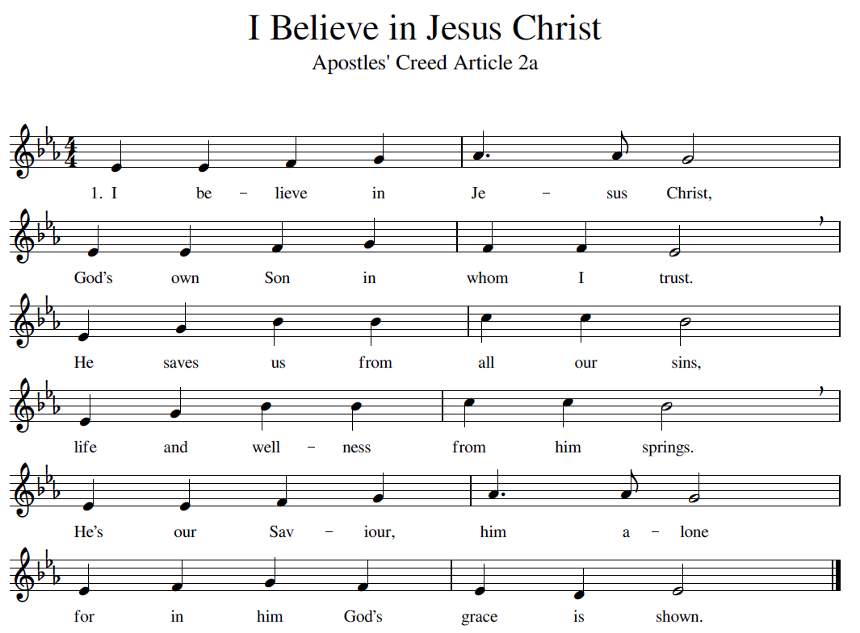

2. Those who look to self or saints
Won’t be freed from sins restraints.
Though they boast of him in words
They, in fact, deny the Lord.
Place your faith in him alone.
For our sins he did atone.

(For the melody: https://www.youtube.com/watch?v=D9dVNBgQX7Q or search Youtube for “Redhead Ajalon” – the song you need is a version of Psalm 51: “God, be merciful to me”).

