Lesson 18: Messiah. Christ. Anointed.

Memory work
You may also memorize verses 3-5 of the song on the other side of this sheet.

31. Q. Why is He called Christ, that is, Anointed?
A. Because He has been ordained by God the Father,
and anointed with the Holy Spirit,
to be
our chief Prophet and Teacher,
who has fully revealed to us the secret counsel and will of God concerning our redemption;
our only High Priest,
who by the one sacrifice of His body has redeemed us,
and who continually intercedes for us before the Father;
and our eternal King,
who governs us by His Word and Spirit,
and who defends and preserves us in the redemption obtained for us.

32. Q. Why are you called a Christian?
A. Because I am a member of Christ by faith and thus share in His anointing,
so that I may
as prophet confess His Name,
as priest present myself a living sacrifice of thankfulness to Him,
and as king fight with a free and good conscience against sin and the devil in this life,
and hereafter reign with Him eternally over all creatures.

Homework
1.(4) In what ways (more than one!) does the Lord Jesus exceed all other prophets, priests, and kings?
________________________________________________________________________________
________________________________________________________________________________
________________________________________________________________________________
________________________________________________________________________________
________________________________________________________________________________
2. (6) You, too, are a prophet, priest and king. Read over answer 32 above. Now, with respect to the following, indicate whether you are being a prophet, a priest, or a king. (Don’t forget: discussing this with parents or others is allowed )
Tell a friend why you go to church __________________
Pray before your meal _____________________
You were almost rude to your teacher but then stopped yourself. ________________
Put money in the offertory (collection bag) _______________
Pull weeds in the vegetable garden ____________________
Read a Bible story to a young child _____________________
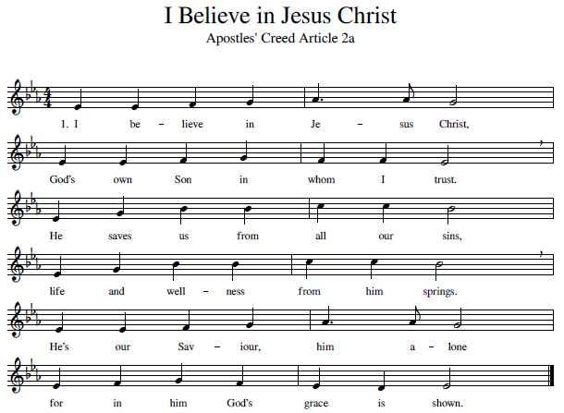
Memorize the stanzas 3, 4 & 5 for next time.

3. He is also called “the Christ”  for he is our great High Priest.  He died on the cursed tree  to redeem and set us free.  Now for us he intercedes  with the Father for our needs. | 4. Christ is our eternal King  who rules over everything.  By his Spirit and his Word  he directs us as our Lord.  Our redemption is secure.  He preserves us evermore.
5. Christ our Prophet does reveal
God’s own counsel and his will.
He’s the one from whom we learn
what his saving death did earn.
Jesus Christ, the Son of God!
We will praise his Name abroad.

