Lesson 20: Review 19

Memory work
If you learned the song version, please use the back of this sheet.
33. Q. Why is He called God’s only-begotten Son, since we also are children of God?
Because _________________________________________________________________________
________________________________________________________________________________
We, however, ____________________________________________________________________
________________________________________________________________________________

34. Q. Why do you call Him our Lord?
Because _________________________________________________________________________
_____________________________________________________________________________
________________________________________________________________________________
_____________________________________________________________________________
And ____________________________________________________________________________
_____________________________________________________________________________
__________________________________________________________________________

Review questions
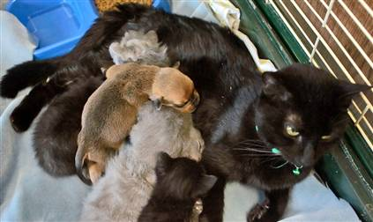
1.(2) What does the word “only-begotten” imply with respect to Jesus?
_________________________________________________________
_________________________________________________________
_________________________________________________________
2.(2) What is a ‘lord’? ________________________________________________________________
________________________________________________________________________________
3.(4) There are basically two lords in this world. Name and describe the character of their lordship.
Name: _________________________________________________________________________
Description: _____________________________________________________________________
________________________________________________________________________________
________________________________________________________________________________
Name: _________________________________________________________________________
Description: _____________________________________________________________________
________________________________________________________________________________
________________________________________________________________________________
4.(2) Complete the following sentence: To have Jesus as lord means ____________________________

Song Version of Memory Work

1. Jesus ____________________________________________________________________________
Begotten ________________________________________________________________________
He _____________________________________________________________________________
We _____________________________________________________________________________
By ___________________________

2. Jesus ____________________________________________________________________________
He _____________________________________________________________________________
Jesus ___________________________________________________________________________
--not ___________________________________________________________________________
He _____________________

