Lesson 25: He Comes To Judge

Coming? - fill in for yourself
Would you like the Lord Jesus to come back soon? ________ because __________________________
________________________________________________________________________________
________________________________________________________________________________

The appearance of the Lord
1. Look up Exodus 19:16-19. Name 5 things that were present when the LORD spoke from Mt Sinai.
________________________________________________________________________________
________________________________________________________________________________
________________________________________________________________________________
What was the reaction of the people? __________________________________________________
2. Look up Hebrews 12:21. How did Moses feel? ___________________________________________
3. Look up 1 Thessalonians 4:16. When the Lord Jesus comes, what will sound? __________________
________________________________________________________________________________
4. Look up Revelation 1:12-17. How did John the apostle react to the appearance of the Lord Jesus?
________________________________________________________________________________

When the Lord appears
When Christ returns __________________________________________________________________
________________________________________________________________________________
- those who ______________________________________________________________________
- those who ______________________________________________________________________

Bible Study: Matthew 25:31-46
1. Name two things from the beginning of this passage that indicate the final judgement will be an impressive event.
________________________________________________________________________________
________________________________________________________________________________
________________________________________________________________________________
2. Who does Jesus refer to as “sheep”? ___________________________________________________
3. Who does Jesus refer to as “goats”? ___________________________________________________
4. Why do you think “sheep” and “goats”? ________________________________________________
________________________________________________________________________________
________________________________________________________________________________
________________________________________________________________________________
5. What do the “sheep” receive? ________________________________________________________
6. What does this mean? ______________________________________________________________
________________________________________________________________________________
7. In brief, why do they receive it? ______________________________________________________
________________________________________________________________________________
8. Where will the “goats” go? __________________________________________________________
9. Why? ___________________________________________________________________________
________________________________________________________________________________
________________________________________________________________________________
________________________________________________________________________________

The basic question
When Christ ________________________________________________________________________
________________________________________________________________________________
________________________________________________________________________________
We ________________________________________________________________________________
This means, ________________________________________________________________________
The basic question in our lives is: _______________________________________________________
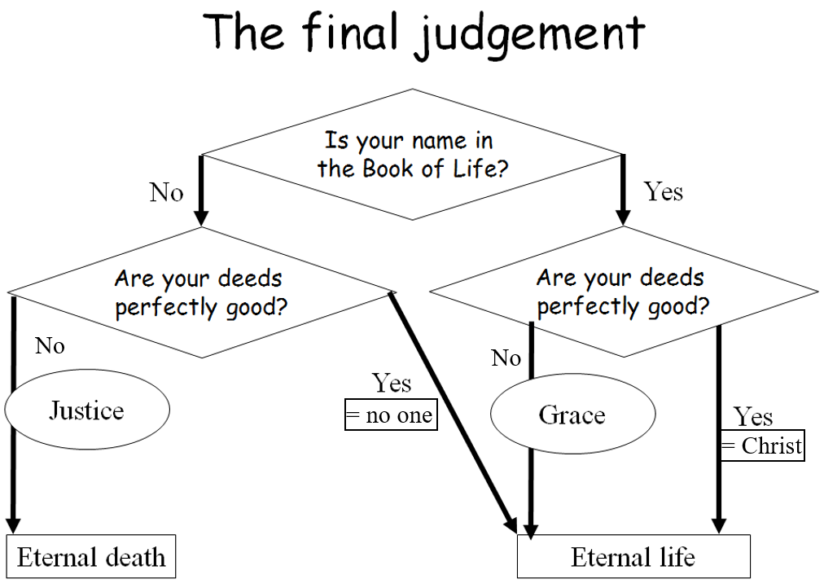
________________________________________________________________________________

The final judgement
If your name is in the Book of Life, you will be ____________________________________________
________________________________________________________________________________
- our works _________________________________________________________________________
________________________________________________________________________________
- they are ___________________________________________________________________________
________________________________________________________________________________
________________________________________________________________________________
________________________________________________________________________________
________________________________________________________________________________
________________________________________________________________________________

Coming? - fill in for yourself
Would you like the Lord Jesus to come back soon? ________ because __________________________
________________________________________________________________________________
________________________________________________________________________________

