Lesson 23: The Christ Lives!

Memory work
You may also memorize 3 stanzas of the song on the other side of this sheet.

42. Q. Since Christ has died for us, why do we still have to die?
A. Our death is not a payment for our sins,
but it puts an end to sin
and is an entrance into eternal life.

45. Q. How does Christ’s resurrection benefit us?
A. First,
by His resurrection He has overcome death,
so that He could make us share
in the righteousness which He had obtained for us by His death.
Second,
by His power we too are raised up to a new life.
Third,
Christ’s resurrection is to us a sure pledge of our glorious resurrection.

Homework
1.(4) Look up 1 Corinthians 15:15-18. Name two reasons why the church must preach the resurrection of the Christ.
________________________________________________________________________________
________________________________________________________________________________
________________________________________________________________________________
________________________________________________________________________________
2.(3) In many liberal (free-thinking) churches the resurrection of Christ is considered symbolical. Jesus did not physically rise from the dead. Rather, He has arisen by living on in the hearts of His followers. Why would you say they are wrong?
________________________________________________________________________________
________________________________________________________________________________
________________________________________________________________________________
3.(3) In the Book of Praise, Hymn 31 begins with “Christ has risen”, while Hymn 32 says “Christ the Lord is risen today.”
What is the difference? _______________________________________________________
Some people object to Hymn 32. What would be a wrong way to understand this? _________________
________________________________________________________________________________
________________________________________________________________________________
What would be the right way to understand this? ___________________________________________
________________________________________________________________________________
Should we sing Hymn 32 if it can be misunderstood? ________________________________________

Alternative Memory Work
Melody: The Dutch Easter hymn: Daar juicht een toon, daar klinkt een stem

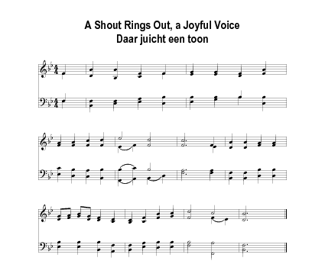
1. Alleluia! When Christ was raised
He conquered death. Let him be praised!
He lets us share the righteousness
Which he, in death, obtained for us.

2. And by his power we too are raised
Unto new lives by which he’s praised.
No longer dead but now alive!
For godliness we’ll always strive.

3. His resurrection promises
And is a steadfast pledge to us
That we in glory will be raised.
Alleluia! Let Christ be praised.

