Lesson 25: He Comes To Judge

Coming?
Would you like the Lord Jesus to come back soon? ________ because __________________________
________________________________________________________________________________

Bible Study: Matthew 25:31-46
1. Name two things from the beginning of this passage that indicate the final judgement will be an impressive event.
________________________________________________________________________________
________________________________________________________________________________
________________________________________________________________________________
2. Who does Jesus refer to as “sheep”? ___________________________________________________
3. Who does Jesus refer to as “goats”? ___________________________________________________
4. What sense do you make of these comparisons? __________________________________________
________________________________________________________________________________
________________________________________________________________________________
________________________________________________________________________________
5. What do the “sheep” receive? ________________________________________________________
6. What does this mean? ______________________________________________________________
________________________________________________________________________________
7. In brief, why do they receive it? ______________________________________________________
________________________________________________________________________________
8. Where will the “goats” go? __________________________________________________________
9. Why? ___________________________________________________________________________
________________________________________________________________________________
________________________________________________________________________________
________________________________________________________________________________

The basic question
When Christ ________________________________________________________________________
________________________________________________________________________________
________________________________________________________________________________
We were made _____________________________________________________________________
This means, ________________________________________________________________________
The basic question in our lives is: _______________________________________________________
________________________________________________________________________________
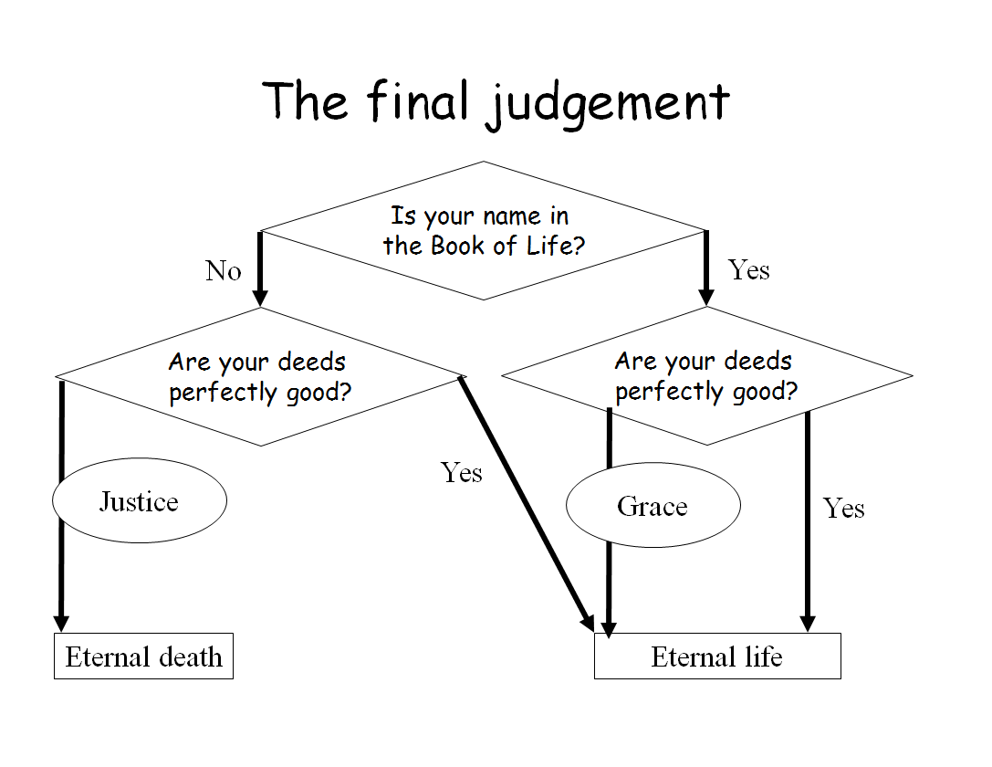
No
= no one
= Christ
No

The final judgement
Revelation 20 indicates the final outcome is based on our names being in the Book of Life. Matthew 25 relates it to our activities in life.
If your name _______________________________________________________________________
________________________________________________________________________________
________________________________________________________________________________
- they are ________________________________________________________________________
________________________________________________________________________________
- they are ________________________________________________________________________
________________________________________________________________________________
________________________________________________________________________________
________________________________________________________________________________
________________________________________________________________________________
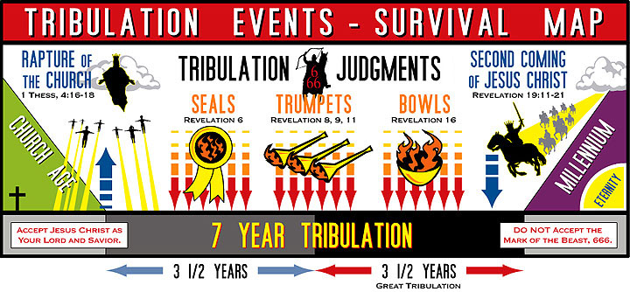

Millennialism
The problem with millennialism is ______________________________________________________
________________________________________________________________________________
When reading the Bible _______________________________________________________________
________________________________________________________________________________
________________________________________________________________________________
________________________________________________________________________________
________________________________________________________________________________

Two views
The majority of Reformed people will hold to _____________________________________________
________________________________________________________________________________
________________________________________________________________________________
________________________________________________________________________________
A minority holds to __________________________________________________________________
________________________________________________________________________________
________________________________________________________________________________
________________________________________________________________________________
Both believe the 1000-year reign runs from _______________ to _____________________________.

Coming?
Would you like the Lord Jesus to come back soon? ________ because __________________________
________________________________________________________________________________
________________________________________________________________________________

