Lesson 28: Your Future is Safe!

Survey: What do people think is most important in life?
Use an ‘o’ to mark what you think would be the first, second, third choice of most people living in Langley. Use an ‘x’ to mark your personal first, second, and third choice.
 | 1st | 2nd | 3rd
Make lots of money, have lots of stuff
Have lots of friends
A girlfriend/boyfriend
Marry and have a family
Have real adventures
Be healthy
Peace on earth
Have a strong faith
All people treated fairly
Study and have a career
Be honest
Lots of time for recreation, holidays
Have lots of fun in life (live for the weekend)
Do something really special
Become famous

What God has promised
Those who believe have been promised much: _____________________________________________
________________________________________________________________________________

Forgiveness of Sins
In _______________________________________________________________________________
________________________________________________________________________________
________________________________________________________________________________
Forgiveness of sins __________________________________________________________________
________________________________________________________________________________

Bible Study: A Resurrection? – Matthew 22:23-33
1. What is the tense of the verb “to be” in verse 32? _________________________________________
2. What does the tense say about Abraham, Isaac, and Jacob? _________________________________
________________________________________________________________________________
3. Where did death come from? _________________________________________________________
4. Which is stronger, the power of God or the power of death? ________________________________
5. Given verse 30, what mistake did the Sadducees make in their reasoning? _____________________
________________________________________________________________________________
________________________________________________________________________________

Life has Three Stages
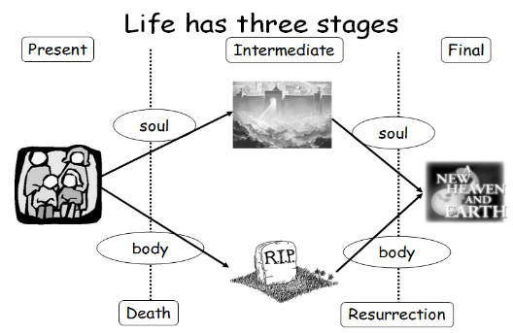
______________: Soul and body are _____________________
__________________________________________________
_______________: Soul and body are _____________________
__________________________________________________
_______________: Soul and body are _____________________
__________________________________________________

Death and Resurrection
Upon dying, ________________________________________________________________________
________________________________________________________________________________
________________________________________________________________________________
________________________________________________________________________________
Your soul = everything that makes you the individual person you are: your desires, memories, thoughts, character etc.
Life in heaven _______________________________________________________________________
________________________________________________________________________________
________________________________________________________________________________
Hence also people in heaven ___________________________________________________________
________________________________________________________________________________
________________________________________________________________________________
________________________________________________________________________________
________________________________________________________________________________

A New Creation
When Christ returns, _________________________________________________________________
________________________________________________________________________________
________________________________________________________________________________
This will be _________________________________________________________________________
It will be ___________________________________________________________________________
________________________________________________________________________________
It will be ___________________________________________________________________________
________________________________________________________________________________
We will be _________________________________________________________________________

