Lesson 28: Your Future is Safe!

Thoughts on the purpose of life and existence

What is important to you in life? What is the purpose of your life? What are your goals in life?
________________________________________________________________________________
________________________________________________________________________________
________________________________________________________________________________

What God has promised
Those who believe have been promised much: __________________________________________
________________________________________________________________________________

Forgiveness of Sins
In Christ ________________________________________________________________________
________________________________________________________________________________
________________________________________________________________________________
________________________________________________________________________________
Forgiveness of sins ________________________________________________________________
________________________________________________________________________________
________________________________________________________________________________

Bible Study: A Resurrection? – Matthew 22:23-33
1. What is the tense of the verb “to be” in verse 32? _________________________________________
2. What does the tense say about Abraham, Isaac, and Jacob? _________________________________
________________________________________________________________________________
3. Where did death come from? _________________________________________________________
4. Which is stronger: God’s power or death’s power? ____________________________________
5. Given verse 30, what mistake did the Sadducees make in their reasoning? _____________________
________________________________________________________________________________
________________________________________________________________________________

Life has Three Stages
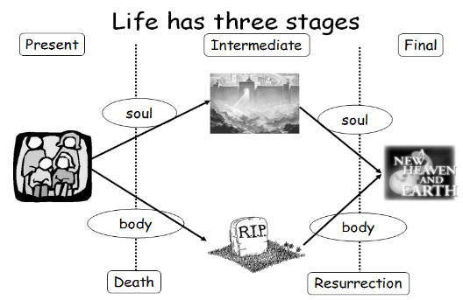
______________: Soul and body are _____________________
__________________________________________________
_______________: Soul and body are _____________________
__________________________________________________
_______________: Soul and body are _____________________
__________________________________________________

Soul sleep
Some Christians believe _______________________________________________________________
This view of things is called ____________________.
This view is held by ____________________________________ and, to an extent, by _____________
_______________________________.
However, the Bible is clear that _________________________________________________________
______________________________________________________________________________.

Death and Resurrection
Upon dying _____________________________________________________________________
________________________________________________________________________________
________________________________________________________________________________
Your soul = everything that makes you the individual person you are: your desires, memories, thoughts, character etc.
Life in heaven ____________________________________________________________________
But it’s _________________________________________________________________________
Hence also people in heaven ________________________________________________________
________________________________________________________________________________
________________________________________________________________________________
________________________________________________________________________________
________________________________________________________________________________

A New Creation
When Christ returns _______________________________________________________________
________________________________________________________________________________
________________________________________________________________________________
This will be ______________________________________________________________________
________________________________________________________________________________
It will be ________________________________________________________________________
________________________________________________________________________________
________________________________________________________________________________
It will be a _______________________________________________________________________
________________________________________________________________________________
________________________________________________________________________________
We will be _______________________________________________________________________

