# Lesson 11 – Review 10

## Memory Work

### 92. Q. What is the law of God?

*God spoke all these words:*

*I am ____________ your ______, who brought you out of ______________________, out of the house of slavery. 1. You shall have __________________ before me.*

*2. You shall not make for yourself a ________________________ or any likeness of anything that is in ____________ above or that is in the _______________ beneath, or that is in the ___________ under the earth. You shall _________________ to them or ___________ them, for I, the LORD your God, am a _____________ God, visiting ________________ of the fathers on the children to the _______ and ______________ generation of those who ____________ me, but showing steadfast love to ________________ of those who ____________ me and _________ my commandments.*

*3. You shall not take the name of the LORD your God ____________, for the LORD will not hold him _____________ who takes his name _______________.*

*4. Remember the ________________, to keep it _________. _____ days you shall ___________, and do all your __________, but the ____________ day is a ___________ to the __________ your God. On it you shall not do ______________, you, or your son, or your ______________ , your male servant, or your female servant, or your _________________, or the ___________________who is within your gates. For in _______ days the LORD made ______________ and ___________, the sea, and all that is in them, and rested on the _______________day. Therefore the LORD ______________ the ____________ day and made it _____________.*

*5. _____________ your ____________ and your ______________, that your days may be long in the land that the LORD your God is giving you. 6. You shall not ________________.*

*7. You shall not commit _________________. 8. You shall not ___________________.*

*9. You shall not ______________________________ against your neighbour.*

*10. You shall not _____________ your neighbour’s house; you shall not _____________ your neighbour’s wife, or his male servant, or his female servant, or his ox, or his donkey, or _____________ that is your neighbour’s.*

### 93. Q. How are the commandments divided?

*Into ___________________________________________________________________*

*The ____________________________________________________________________________*

*The ____________________________________________________________________________*

Review questions are on the other side of this page

## Review Questions

1. (3) What is a covenant?

_______________________________________________________________________________

________________________________________________________________________________

________________________________________________________________________________

2. (2) Fill in the blanks:

God promises ___________________________ and _________________________ obedience

Man __________________ obedience and ________________ ___________________________

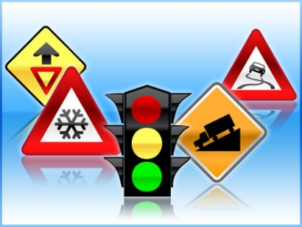3. (3) Why can the law of God be referred to as “the law of freedom”?

____________________________________________________

____________________________________________________

____________________________________________________

____________________________________________________

____________________________________________________

4. (2) The law tells us we have been “saved from Egypt”? Yet most of us have never been to Egypt, certainly not in a way that we needed to be “saved” from it. What does it mean for us today that we have been saved “from Egypt”? ________________________________________________________________________________

________________________________________________________________________________

________________________________________________________________________________