# Lesson 12: Worship God As He Wants It Done.

## Bible Study: Exodus 32:1-8

1. Why did the Israelites want to make an image? ___________________________________________

________________________________________________________________________________

2. What did the image they made look like? _______________________________________________

3. What did the Israelites say of the image? _______________________________________________

________________________________________________________________________________

________________________________________________________________________________

4. For whom was the festival organized the next day? _______________________________________

5. Did the LORD appreciate what the Israelites had done? ___________________________________

## Bible Study: 1 Kings 12:25-33

1. Why did King Jeroboam not want the Israelites to go to the temple? __________________________

________________________________________________________________________________

2. What did King Jeroboam then make? __________________________________________________

3. What did he say of these images? _____________________________________________________

________________________________________________________________________________

4. Where were these images placed? _____________________________________________________

5. Did the LORD approve of what Jeroboam did? __________________________________________

6. Jeroboam did 3 more things with respect to the worship of God. What were they?

________________________________________________________________________________

________________________________________________________________________________

________________________________________________________________________________

________________________________________________________________________________

________________________________________________________________________________

________________________________________________________________________________

## 1st and 2nd – the difference

The first commandment is about worshiping _______________________________________________

________________________________________________________________________________

________________________________________________________________________________

The second commandment is about worshiping ____________________________________________

________________________________________________________________________________

________________________________________________________________________________

The first commandment is about _________ you are to worship.

The second commandment is about _________ you are to worship.

## Against 1st or 2nd commandment?

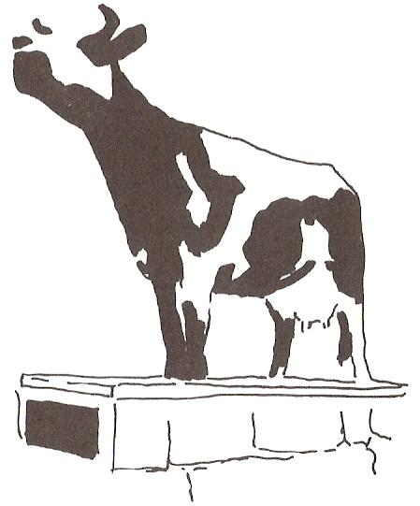Fill in a 1 behind the sins against the first commandment and a 2 behind the sins against the second commandment.

Worship Jupiter: ___

Thinking “God is never angry, only loving”: ___

Putting your trust in money: ___

Never ask God to forgive sins: ___

Represent God with a golden calf: ___

A church service without a sermon: ___

Consulting spirits through a medium: ___

## Worship

A worship service is a moment where _________________________________________________.

This meeting is at ______________________________.

A worship service is a celebration of _________________________________________________.

Hence *______________* decides how it takes place.

While God does allow much room for human input, it will always have to be within the confines of what God has commanded and forbidden.

This is known as the _________________________________________________________________.

The program for a worship service is called ______________________. (From a Greek word meaning, ‘service’)

A worship service has the character of a _________________ between _______ and ______________.

The _______________ represents God.

In some instances (e.g., ______________) the minister speaks on behalf of the people.

## Visuals (time permitting)

Visuals during services are _____________________________________________________________

________________________________________________________________________________

________________________________________________________________________________

________________________________________________________________________________

________________________________________________________________________________

## 2nd Commandment

Don’t _____________________________________________________________________________

And don’t __________________________________________________________________________

Do ________________________________________________________________________________