# Lesson 14: Catch Your Breath And Worship God

## Four Concepts

Week: ____________________________________________________________________________

________________________________________________________________________________

Holy: ______________________________________________________________________________

Sabbath: Hebrew “shabbat” = __________________________________________________________

- In relation to _______________ it means _______________

- Not the name of ________________________ but of ___________________________________

(*Just like the English word “holiday”)*

Remember, celebrate: _________________________________________________________________

________________________________________________________________________________

## Bible Study: Exodus 20: 8-11 and Deuteronomy 5:12-15 (we’ll do them together)

1. What reason does Exodus 20 give for keeping the Sabbath day as a special day?

________________________________________________________________________________

________________________________________________________________________________

________________________________________________________________________________

2. What reason does Deuteronomy 5 give for keeping the Sabbath day as a special day?

________________________________________________________________________________

________________________________________________________________________________

________________________________________________________________________________

3. Does the Exodus 20 reason still apply for Christians today?

_______ because _________________________________________________________________

________________________________________________________________________________

4. Does the Deuteronomy 5 reason still apply for Christians today?

_______ because _________________________________________________________________

________________________________________________________________________________

________________________________________________________________________________

## Ministry of the Gospel and schools

The fourth commandment “to rest” ______________________________________________________

____________________________________________________________________________ because

___________________________________________________________________________________

Thus God’s people are to make sure:

- _____________________________: _________________in which to preach, ________________

____________________for preaching; and _______________ who preach.

- education with a view to __________________________________________________________

________________________________________________________________________________

- education is also a form of ________________: we are __________________________________

________________________________________________________________________________

and what _______________________________________________________________________

________________________________________________________________________________

## Time to Hear the Preaching

The preaching of the Gospel should not only *happen*, it also has to be *heard*.

God commands us ___________________________________________________________________

___________________________________________________________________________________

___________________________________________________________________________________

___________________________________________________________________________________

___________________________________________________________________________________

## Take Your Rest

God does not want us to be a slave to our daily activities. Hence He commands us _________________

___________________________________________________________________________________

The deeper meaning to this is __________________________________________________________

___________________________________________________________________________________

After all, ___________________________________________________________________________

___________________________________________________________________________________

___________________________________________________________________________________

## Do’s and Don’ts

Family rules with respect to the Sunday should be __________________________________________

___________________________________________________________________________________

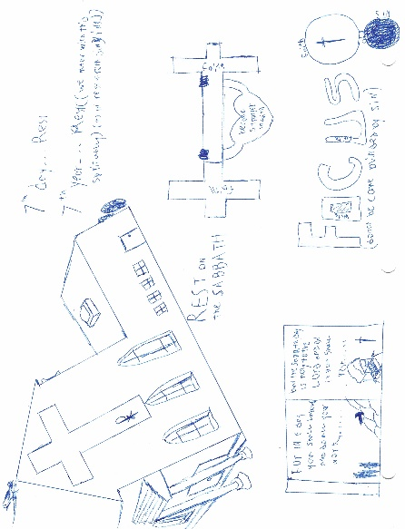 ________________________________________________________________________________

______________________________________________

______________________________________________

______________________________________________

______________________________________________

## Design a poster (on the back of your homework sheet)