Lesson 16 – Review 15

Memory Work

104.Q. What does God require in the fifth commandment?
That ______________________________________________________________________________
to _____________________________________________________________________________
and to __________________________________________________________________________
___________________________________________________________________________________
to __________________________________________________________________________
and also ________________________________________________________________________
________________________________________________________________________________since it is __________________________________________________________________________

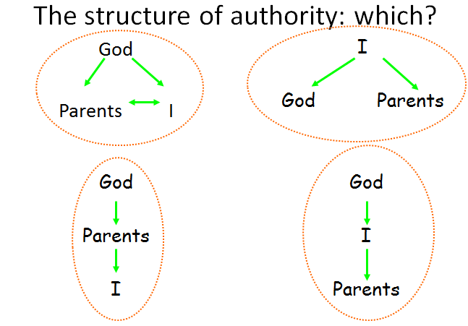
Review Questions
1.(2) Circle the correct (Biblical) scheme in the diagram alongside.

2.(2) Why do we have to respect authorities?
_______________________________________
_______________________________________

3.(1)What is meant by official authority? ____________
________________________________________________________________________________
4.(1) What is meant by personal authority? _______________________________________________
________________________________________________________________________________
5.(1) In the following sentences, fill in either “official” or “personal”.
A policeman arresting someone for shoplifting is acting with __________________ authority.
A celebrity promoting eating a Big Mac is acting with ____________________ authority.
6.(2) Give two reasons why we should honour our parents and have respect for them.
________________________________________________________________________________
________________________________________________________________________________
________________________________________________________________________________
7.(1) True or False?
You only have to obey a teacher when you like the teacher. ___________
If your mom tells you to lie to the minister about something, you have to listen to your mom. ______

