# Lesson 18: Respect For Possessions

## Ownership

God ______________________________________________________________________________

____________________________________. Our possessions _____________________________

________________________________________________________________________________

## Bible Study: 1 Timothy 6:6-10

1. What is great gain? _________________________________________________________________

2. What did we bring into this world as our own when we were born? ___________________________

3. What will we take out of this world as our own when we die? _______________________________

4. What should we be content with? __________________________________________

5. What do people who desire to be rich fall into? ___________________________________________

________________________________________________________________________________

________________________________________________________________________________

6. What is a root of all kinds of evil? _______________________________________

7. What has happened to some people, who crave for money? _________________________________

________________________________________________________________________________

________________________________________________________________________________

8. Does this passage say it is wrong to be rich? _______because _______________________________

________________________________________________________________________________

### Greed is sin

________________________________________________________________________________

It could be

- only save your money and never spend any of it

- have others always pay for you and never pay for others

________________________________________________________________________________

### Squandering is sin

________________________________________________________________________________

________________________________________________________________________________

It means you only spend, never save, never think of the future

________________________________________________________________________________

### Usury is sin

________________________________________________________________________________

________________________________________________________________________________

For example: loaning someone $10 and asking $20 in return.

________________________________________________________________________________

________________________________________________________________________________

### Robbery is sin

________________________________________________________________________________

________________________________________________________________________________

Fraud: to take money or something without delivering or doing what was promised

Thievery: physically taking something from someone else when you’re not allowed to

### Caring is good

________________________________________________________________________________

________________________________________________________________________________

________________________________________________________________________________

## Stewardly

________________________________________________________________________________

To do _____________ to support ourselves

To do _____________ to support those for whom we are responsible

To do _____________ to care for those who cannot care for themselves

Good stewards ______________________________________________________________________

________________________________________________________________________________

________________________________________________________________________________

________________________________________________________________________________

________________________________________________________________________________

## Don’t be ________________ but be ___________________________________

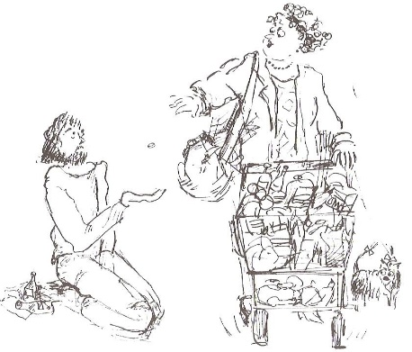To begin with, it’s all God’s.

And in the end, it’s all God’s.

## 8th commandment

Don’t___________________________________________________

_____________________________________________________

Do _____________________________________________________

_____________________________________________________