# Lesson 21 – Review 20

## Memory Work

### 113.Q. What does the tenth commandment require of us?

*That not ___________________________________________________________________________*

*_______________________________________________________________________________*

*should _________________________________________________________________________*

*Rather _____________________________________________________________________________*

*we should _______________________________________________________________________*

*and ____________________________________________________________________________*

### 114.Q. But can those converted to God keep these commandments perfectly?

*____________*

*In this __________________________________________________________________________*

*____________________________________________________________________________*

*Nevertheless, ______________________________________________________________*

*____________________________________________________________________________*

## Review Questions

1.(3) True or False:

God is satisfied if you’re in church, even if you don’t want to be. _______________

God is fine with you disliking a person as long as you don’t show it. ________________

God commands us not just *to do* good but *to want to do* good. __________

2.(2) What was Calvin’s motto about? ____________________________________________________

*____________________________________________________________________________*

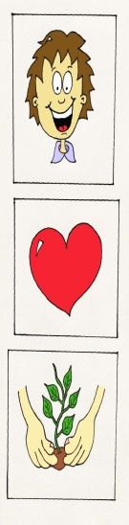3.(5) Fill in the blanks:

Head: ___________ what God expects

I have to _____________________________________________________________

I need to pray for ______________________________________________________

Heart: ___________ what God expects

I have to ____________________________________________________________

I need to pray to _____________________________________________________

Hands: __________ what God expects

I have to _____________________________________________________________

I need to pray for ______________________________________________________