# Lesson 22: Our Heavenly Father

## Praying to ... whom?

Describe briefly how you see (picture) God when you pray. Is He a policeman, a help-line, a father, a Santa Claus, a wise but powerless old man, a manager, a judge, a...?

________________________________________________________________________________

________________________________________________________________________________

________________________________________________________________________________

Describe also how you feel in your prayer: frightened, relaxed, overawed, bored,...

________________________________________________________________________________

________________________________________________________________________________

## Bible Study: John 17:1-26

1. Who is praying here? ______________________________________

2. When did He pray this? _____________________________________________________________

3. How many times do you count the name “Father” in this prayer and in which verses? ___________

________________________________________________________________________________

4. In the verses 11 & 25 adjectives are used in combination with “Father”. Which? ________________

________________________________________________________________________________

5. Why would these adjectives have been used in this prayer? _________________________________

________________________________________________________________________________

## Father

Because we have been created by God, ________________________________________________

________________________________________________________________________________

However, ________________________________________________________________________

________________________________________________________________________________

________________________________________________________________________________

God restores _____________________________________________________________________

________________________________________________________________________________

Thus believers ____________________________________________________________________

________________________________________________________________________________

## Children of God

Christ is _________________________________________________________________________

We are __________________________________________________________________________

The difference between Christ and us is the following. ____________________________________

________________________________________________________________________________

________________________________________________________________________________

________________________________________________________________________________

## Fathers and Children

Write some words down that describe how children relate in a good and proper way to fathers.

________________________________________________________________________________

Write some words down that describe how fathers relate in a good and proper way to children.

________________________________________________________________________________

## Earthly Fathers and Heavenly Father

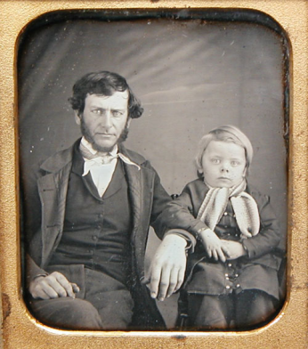God compares Himself with earthly fathers.

This means ____________________________________________________

______________________________________________________________

______________________________________________________________

However,

______________________________________________________________

________________________________________________________________________________

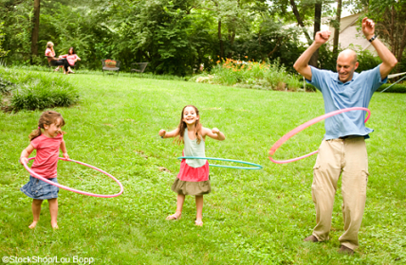 Our understanding _______________________________________________

______________________________________________________________

______________________________________________________________

______________________________________________________________

______________________________________________________________

Besides, _________________________________________________________________________

________________________________________________________________________________

## In Heaven

________________________________________________________________________________

________________________________________________________________________________

________________________________________________________________________________

## Father!

Christians pray to God.

________________________________________________________________________________

________________________________________________________________________________

________________________________________________________________________________

________________________________________________________________________________