# Lesson 25: Your Will Be Done

## God’s Will

There’s a lot of confusion about the third petition

________________________________________________________________________________

1. ___________________________________

__________________________________ OR

2. ___________________________________

_____________________________________

## Your Will Be Done

IS NOT

________________________________________________________________________________

BUT

________________________________________________________________________________

## Bible Study: Luke 22:39-44 & Hebrews 5:7-8

Read Luke 22:39-44

1. Where did Jesus go? ________________________________________________________________

2. How was He feeling? _______________________________________________________________

3. What did He want to have the Father do? _______________________________________________

4. What did He ask the Father? _________________________________________________________

Read Hebrews 5:7-8. This refers back to Luke 22:39-44.

5. Why was the prayer of Jesus heard? ___________________________________________________

________________________________________________________________________________

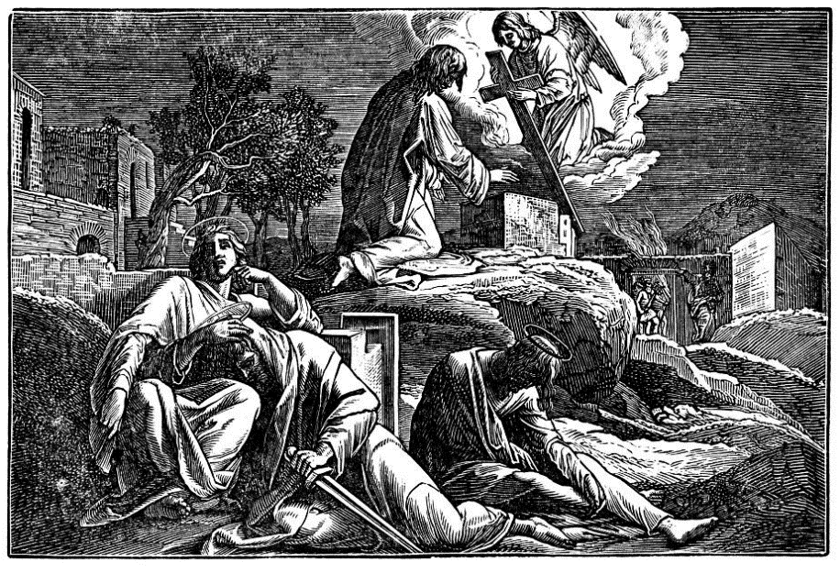6. What had Jesus learned? ____________________________________________________________

## Obeying God

________________________________________________________________________________

________________________________________________________________________________

- everybody does it

- I’m not hurting anyone when I do this

- I do mean well

- In my case it’s different

- Okay, it’s wrong. But I’m not an unbeliever

- We’re all sinful, aren’t we?

________________________________________________________________________________

________________________________________________________________________________

________________________________________________________________________________

## Angels

Angels are beings ______________________________________

________________________________________________________________________________

There are basically two types of angels:

______________

_____________________________________________________________________________

_____________________________________________________________________________

______________

_____________________________________________________________________________

_____________________________________________________________________________

## The Third Petition

Is not about ___________________ but about ______________

___________________________________________________

Is directly related to us _________________________________

____________________________________________________

____________________________________________________

____________________________________________________