# Lesson 26: Give Us This Day Our Daily Bread

## All things come from God

________________________________________________________________________________

We should never forget this. _________________________________________________________

________________________________________________________________________________

But both ______________________________ receive their food from God.

Praying the fourth petition is ________________________________________________________

## Pray for bread?

In the past _______________________________________________________________________

________________________________________________________________________________

________________________________________________________________________________

However, even with all our modern capabilities _________________________________________

________________________________________________________________________________

The food on our table is not just ______________________________________________________

It is the result of __________________________________________________________________

## Bible Study: Psalm 127:1-2

1. Who is to build the house? ___________________________________________________________

2. Who is to watch over the city? ________________________________________________________

3. What is in vain? ___________________________________________________________________

________________________________________________________________________________

4. Why? ___________________________________________________________________________

________________________________________________________________________________

5. Should we then not bother with work? _________________________________________________

________________________________________________________________________________

## Whom do we trust?

We _____________________________________________________________________________

But ____________________________________________________________________________

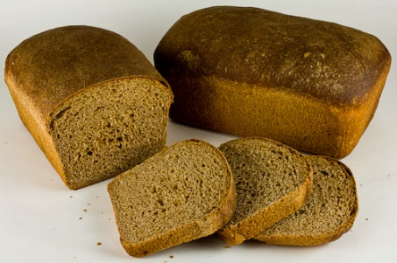 We _____________________________________________________________________________

## Bible Study: Deuteronomy 8:10-20

1. What are we to do when we have eaten our fill? __________________________________________

________________________________________________________________________________

2. How does a person show he is forgetting the Lord? _______________________________________

________________________________________________________________________________

3. What happens easily to people who are well off? _________________________________________

________________________________________________________________________________

4. What may well off people say to themselves? ____________________________________________

________________________________________________________________________________

________________________________________________________________________________

5. Is that true? _____ for ______________________________________________________________

________________________________________________________________________________

6. How does forgetting the Lord also show in your life? ______________________________________

________________________________________________________________________________

7. What will the Lord do when we forget the Lord? _________________________________________

________________________________________________________________________________

## Praying for all men

“Us” in the fourth petition is ________________________________________________________

We pray that _____________________________________________________________________

________________________________________________________________________________

And if we ourselves _______________________________________________________________

 ______________________________________________________________

God gives daily sustenance through

___________________________________________________________

___________________________________________________________

___________________________________________________________

## The fourth petition

- We acknowledge ___________________________________________________________________

________________________________________________________________________________

- We receive ________________________________________________________________________

________________________________________________________________________________

________________________________________________________________________________