# Lesson 25: Your Will Be Done

## Memory work (q&a 124 OR Hymn 63:4)

|  |  |
| --- | --- |
| 124.Q. What is the third petition? *A. Your will be done, on earth as it is in heaven.*  *That is:*  *Grant that we and all men may deny our own will,*  *and without any murmuring obey Your will,*  *for it alone is good.*  *Grant also that everyone*  *may carry out the duties of his office and calling*  *as willingly and faithfully as the angels in heaven.* | Hymn 63:4 *O Father, may your will be done*  *on earth below by everyone.*  *May we deny our wilful way,*  *and, without murm’ring, you obey.*  *In all our duties, Lord, may we,*  *like heaven’s angels, faithful be.* |

## Homework

1. (3) If you apply for a job and pass the interview, does this mean it is God's will that you have the job? Even if it means working on Sundays?

_________ because _______________________________________________________________

________________________________________________________________________________

________________________________________________________________________________

________________________________________________________________________________

________________________________________________________________________________

________________________________________________________________________________

2.(3) Does praying for good health fall under the third or fourth petition (or both or neither)? Give reasoning for your answer. *(Maybe discuss with a parent.)*

________________________________________________________________________________

________________________________________________________________________________

________________________________________________________________________________

________________________________________________________________________________

________________________________________________________________________________

3. (4) How do we know what God wants us to do, what His will is?

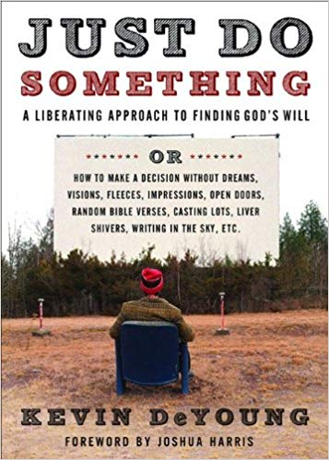________________________________________________________

________________________________________________________ ________________________________________________________ ________________________________________________________ ________________________________________________________ ________________________________________________________ ________________________________________________________

*An excellent book on “God’s will” →*