# Lesson 25: Two Ways To Live (1)

## Memory work – the three cards below

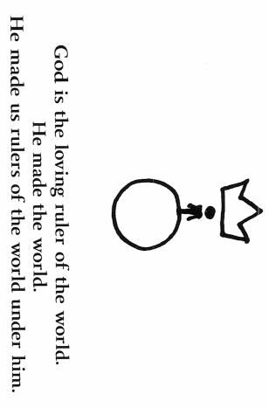For the video: search YouTube for “rote learn two ways to live”. Watch it or listen to it until you can dream it. For the flash cards: learn the picture, then learn the words below the picture, then learn the Bible *text reference*, then learn the question, and finally memorize the Bible text.

## 

