Lesson 19: Review 18

Memory work
If you learned the song version, see the other side for space to write them out.

31. Q. Why is He called Christ, that is, Anointed?
________________________________________________________________________________
________________________________________________________________________________
To be
Our ____________________________________________________________________________
Who ________________________________________________________________________
_____________________________________________________________________________
Our ____________________________________________________________________________
Who _________________________________________________________________________
_____________________________________________________________________________
and _________________________________________________________________________
_____________________________________________________________________________
And our _________________________________________________________________________
_____________________________________________________________________________
_____________________________________________________________________________
_____________________________________________________________________________
_____________________________________________________________________________

32. Q. Why are you called a Christian?
Because ________________________________________________________________________
_____________________________________________________________________________
So that I may
As _____________________________________________________________________________
As _____________________________________________________________________________
_____________________________________________________________________________
And as __________________________________________________________________________
_____________________________________________________________________________
_____________________________________________________________________________

There are 5 review questions on the other side of this sheet

Memorization: song version
3. He is also ________________________________________________________________________
For ____________________________________________________________________________
He _____________________________________________________________________________
To _____________________________________________________________________________
Now ___________________________________________________________________________
With ___________________________________________________________________________
4. Christ is our ______________________________________________________________________
Who ___________________________________________________________________________
By ____________________________________________________________________________
He _____________________________________________________________________________
Our ____________________________________________________________________________
He _____________________________________________________________________________
5. Christ our ________________________________________________________________________
God’s __________________________________________________________________________
He’s ___________________________________________________________________________
What ___________________________________________________________________________
Jesus ___________________________________________________________________________
We _____________________________________________________________________________

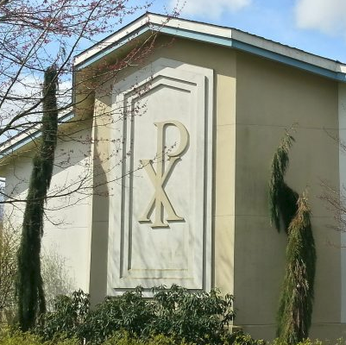
Review questions
1. (1) What is the symbol on this church called? _______________
2. (1) Where does it come from? ___________________________
________________________________________________
3.(4) Anointing is a sign of which two things?
________________________________________________
________________________________________________
4.(2) What was a priest supposed to do? _____________________
________________________________________________
________________________________________________________________________________
5.(2) What does Christ do for you as king? ________________________________________________
________________________________________________________________________________
________________________________________________________________________________
________________________________________________________________________________

