Lesson 01: Sacraments in General

The Origin of Faith
Where does faith come from?
________________________________________________________________________________
________________________________________________________________________________
________________________________________________________________________________
________________________________________________________________________________
________________________________________________________________________________
________________________________________________________________________________

Bible Study: John 20:24-29
1. Which disciple was not present the first time Christ appeared to the disciples? __________________
2. What did the disciples tell him? _______________________________________________________
3. Did he believe them? _____________
4. When would he be willing to believe that Jesus was alive? _________________________________
________________________________________________________________________________
5. Who appeared to the disciples a week later? ______________
6. What did He invite the unbelieving disciple to do? ________________________________________
7. What did He also say to him? ________________________________________________________
8. What was the response of this disciple? _________________________________________________
9. Who did the Lord Jesus call blessed? __________________________________________________
___________________________________________ (Does this include you? _____)

Sacraments are Signs
They are like _______________________________________________________________________
___________________________________________________________________________________
___________________________________________________________________________________
___________________________________________________________________________________

Sacraments are Seals
They are like _______________________________________________________________________
___________________________________________________________________________________
___________________________________________________________________________________
___________________________________________________________________________________

Now Written in My Own Words
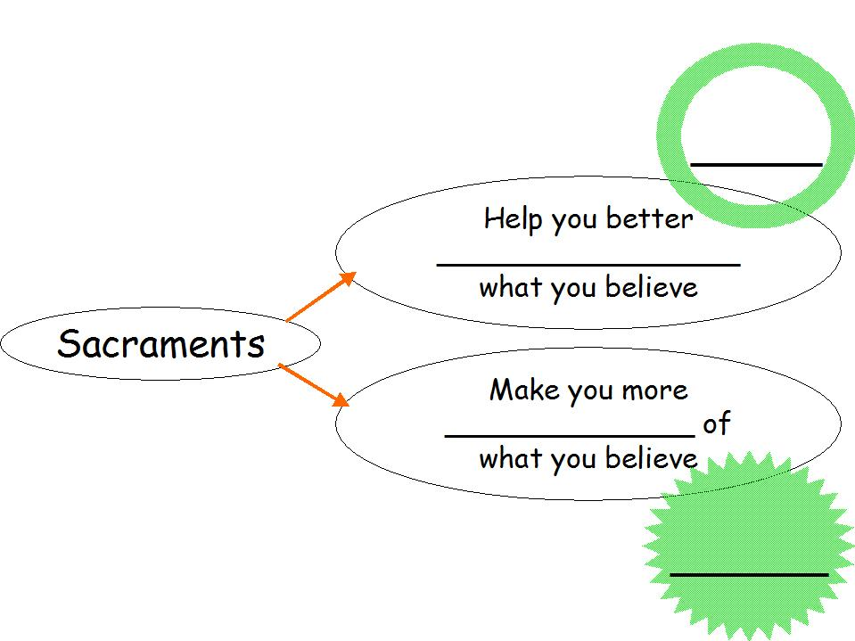
Sacraments are signs because __________________________________________________________
___________________________________________________________________________________
Sacraments are seals because __________________________________________________________
___________________________________________________________________________________

Signs and Seals
Three signs in the Bible that confirm a promise of God: ______________________________________
________________________________________________________________________________

Sacraments and the Senses
We have five senses: sight, hearing, touch, smell and taste. Which of these senses are used when we listen to a sermon? What about when a baby is baptized? Or when we celebrate the Lord's Supper? Write as many senses as you can think of that go with what is in the top row of the table below.
Preaching | Baptism | Lord's Supper

Sacraments: How Many?
The Lord has given us ________________________________________________________________
___________________________________________________________________________________

