Lesson 02: Holy Baptism

Baptism

Bible Study: Acts 8:26-40
1. What was the Ethiopian reading? ______________________________________________________
2. Did he understand what he was reading? ________________________________________________
3. Who was the prophet speaking about? __________________________________________________
Don´t forget to read verse 37 in the text note at the bottom of the page!
4. What did Philip ask the Ethiopian as a condition for being baptized? __________________________
5. Did the Ethiopian believe? ______________
6. What happened next? ________________________________________
7. According to this passage, what is the proper order of the following three: baptism, preaching, faith?
___________________________________________________________________________________
8. Where did the Ethiopian then go? _____________________________________________________
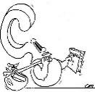
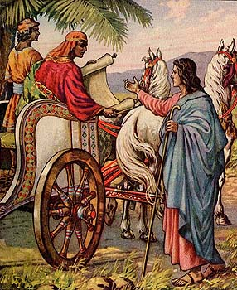

Where does “to baptize” come from?
From the Greek _________________ meaning:
___________________________________________________
___________________________________________________

___________________________________________
___________________________________________
___________________________________________

Baptizing is _____________________________________________________
As milk surrounds the cookie, so Father and Son surround a person.
As milk soaks into the cookie, so the Spirit soaks into a person.
Baptism = __________________________________________________________________________
___________________________________________________________________________________

Baptism is a sign and seal of

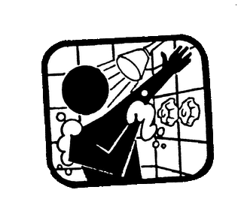
- Being washed
Water ___________________________________________________________
_________________________________________________________________
_________________________________________________________________

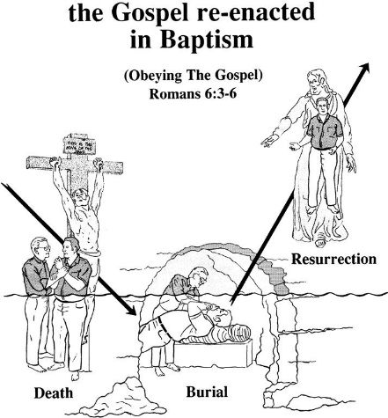
- Dying and coming to life
Under water _____________________________________________
_______________________________________________________
Baptism is
- ____________________________________________________
_____________________________________________________
- ____________________________________________________
_____________________________________________________

- Being incorporated (= become part of the body)
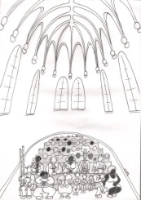
__________________________________________________________________
__________________________________________________________________
__________________________________________________________________
You are part _______________________________________________________
__________________________________________________________________
__________________________________________________________________

Baptism as a sign
Baptism makes clear to everyone:
__________________ ___________________________________ ________________________
__________________ ___________________________________ ________________________

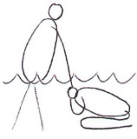
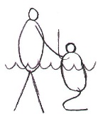
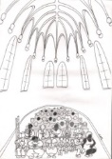
Baptism as a seal
The person being baptized may be certain of
__________________ ___________________________________ ________________________
Justification sanctification incorporation

