Lesson 03 – Review 02

Memory Work

Q. 69. How does holy baptism signify and seal to you that the one sacrifice of Christ on the cross benefits you?
Christ ________________________________________________________________________
as _____________________________________________________________________________
_______________________________________________________________________________
so _____________________________________________________________________________
________________________________________________________________________________

Q. 71. Where has Christ promised that He will wash us with His blood and Spirit as surely as we are washed with the water of baptism?
In ________________________________________________________________________________
_______________________________________________________________________________
_____________________________________________________________________(Mark 16:16)

Review Question
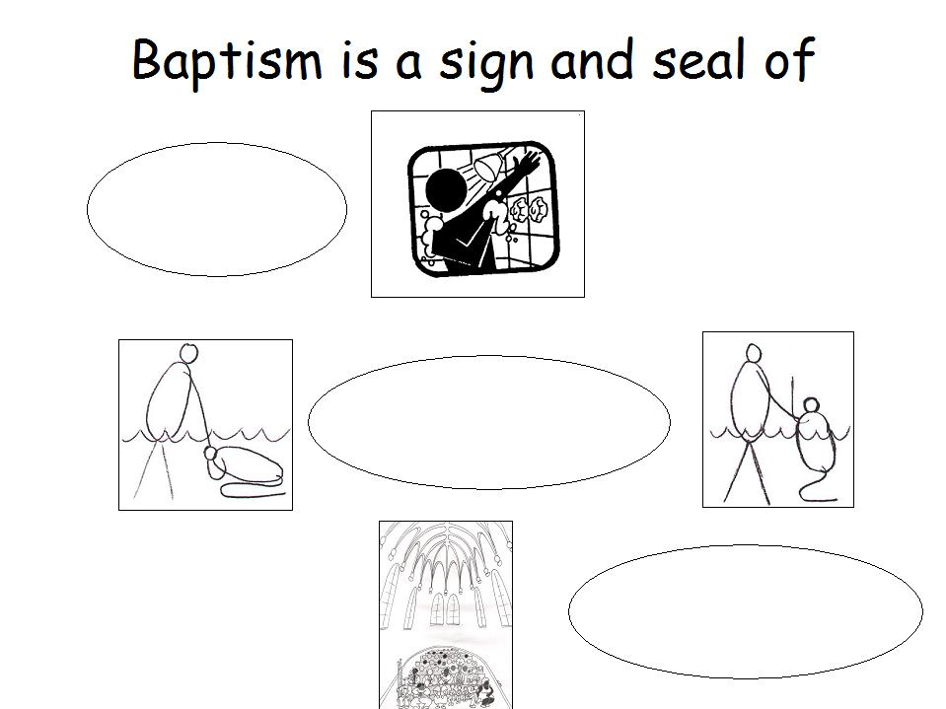
Fill in a description in the 3 ellipses (ovals). Make sure you use the words “sins”, “life” and “belong”

