Lesson 04: Lord's Supper

Lord's Supper

Bible Study: Matthew 26:26-29
1. When did the Lord Jesus institute the Lord's Supper? ______________________________________
2. What did Jesus call the bread? _______________________________
3. What did Jesus call the cup? _________________________________________________________
4. Why would the blood of Christ be poured out? ___________________________________________
________________________________________________________________________________
5. When would Jesus again drink of this fruit of the vine? ____________________________________
________________________________________________________________________________

Elements of Passover
We’ll watch the film twice. The second time through, answer the following questions.
1. Why do the Jews eat unleavened bread? ________________________________________________
________________________________________________________________________________
2. Why do the Jews eat bitter herbs? ____________________________________________________
________________________________________________________________________________
3. Why do the Jews dip their food in liquid? _______________________________________________
________________________________________________________________________________
4. Why do the Jews eat in a reclining position? _____________________________________________
________________________________________________________________________________
5. Discussion question: would Passover have been a somber or a happy feast? ____________________

Why is the Jewish feast of liberation called “Passover”?
 ________________________________________________________________________________
________________________________________________________________________________
________________________________________________________________________________

From Passover to Lord's Supper
Passover: __________________________________________________________________________
________________________________________________________________________________
Lord's Supper: ______________________________________________________________________
________________________________________________________________________________

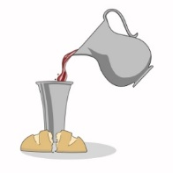
Sign and seal of being forgiven
Bread is ______________ and wine is _________________. It is ________________
_______. The _________________________is the ___________________________
Christ ________________________________________________________________
Thus we are ___________________________________________________________
__________________________________________________________________________________

Sign and seal of being renewed
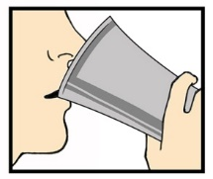
Food and drink ________________________________________________________
_____________________________________________________________________
We share _____________________________________________________________
And thus we have ______________________________________________________
_____________________________________________________________________

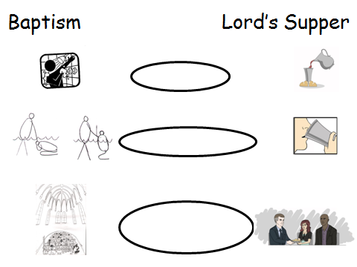
Sign and Seal of being part of the Church
We celebrate ________________________________
___________________________________________
This expresses _______________________________
___________________________________________
___________________________________________
___________________________________________
___________________________________________
___________________________________________

Lord's Supper as a sign
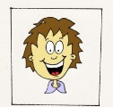
The Lord’s Supper makes clear to everyone:
_________________ ____________________ __________________________________
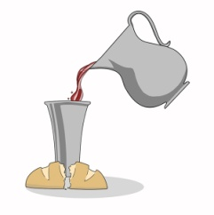
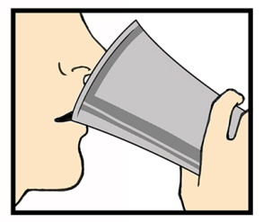
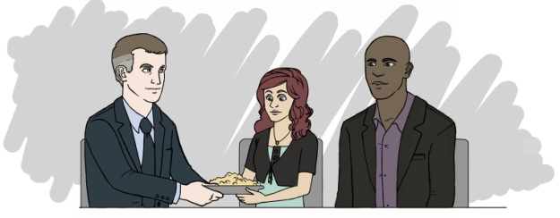
_________________ ____________________ _________________________________

Lord's Supper as a seal
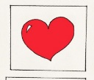
The person partaking of the Lord’s Supper may be certain of
_________________ _____________________ _________________________________
_________________ _____________________ _________________________________

