Lesson 02: Holy Baptism

Baptism

Bible Study: Romans 6:1-14
1. What are we no longer to live in? _______________
What would that mean? ____________________________________________________________
________________________________________________________________________________
2. Being baptized into Christ Jesus means being baptized into _______________________
3. Baptism is like being _________________________
4. Coming out of the water of baptism is like being _________________________________________
5. Why was our old self crucified? _______________________________________________________
________________________________________________________________________________
6. What can Christ no longer do again? ________________
7. What are we to count ourselves? ______________________________and _____________________
8. Who is not to be our master? _________________________________________________________
________________________________________________________________________________
A question to think about. Paul writes that we have died to sin (past tense) and will live with Christ (future tense) - see, for example, verse 8. What is the significance of this use of the past and future tenses in Romans 6?
________________________________________________________________________________
________________________________________________________________________________
________________________________________________________________________________
________________________________________________________________________________
________________________________________________________________________________
________________________________________________________________________________
________________________________________________________________________________

Where does “to baptize” come from?
From the Greek _______________meaning:
________________________________________________________________________________
________________________________________________________________________________
________________________________________________________________________________

Immerse or Sprinkle?
Right from the start, the church practised both immersion and sprinkling. Thus, over time, “baptizo” came to mean more than just “submerge”, it could also mean “sprinkle”
Our Form for Baptism says: ____________________________________________________________
___________________________________________________________________________________
___________________________________________________________________________________

Baptism is a sign and seal of


- Being washed
Water ___________________________________________________________
_________________________________________________________________
_________________________________________________________________

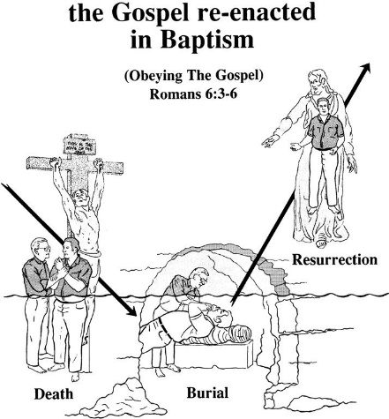
- Dying and coming to life
Under water _____________________________________________
_______________________________________________________
Baptism is
_____________________________________________________
_____________________________________________________
_____________________________________________________
_____________________________________________________

- Being incorporated (= become part of the body)
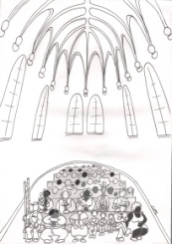
__________________________________________________________________
__________________________________________________________________
__________________________________________________________________
__________________________________________________________________
__________________________________________________________________
__________________________________________________________________

Baptism as a sign
Baptism makes clear to everyone:
__________________ ___________________________________ ________________________
__________________ ___________________________________ ________________________

Baptism as a seal
The person being baptized may be certain of
__________________ ___________________________________ ________________________
Justification sanctification incorporation

