Lesson 4: Lord’s Supper

Lord’s Supper

Bible Study: Luke 22:17-20
1. When did the Lord Jesus institute the Lord’s Supper? ______________________________________
2. When would Jesus drink the fruit of the vine again? _______________________________________
3. What did Jesus call the bread? _______________________________
4. What did Jesus call the cup? _________________________________________________________
5. In this passage, how many times did Jesus and His disciples drink from a cup? _________________

Elements of Passover – question on the video
1. Why do the Jews eat unleavened bread? ________________________________________________
________________________________________________________________________________
2. Why do the Jews eat bitter herbs? _____________________________________________________
________________________________________________________________________________
3. Why do the Jews dip their food in liquid? _______________________________________________
________________________________________________________________________________
4. Why do the Jews eat in a reclining position? _____________________________________________
________________________________________________________________________________
5. Discussion question: would Passover have been a somber or a happy feast? ____________________

Why is the Jewish feast of liberation called “Passover”?
________________________________________________________________________________
________________________________________________________________________________
________________________________________________________________________________

From Passover to Lord’s Supper (3 slides)
Passover: __________________________________________________________________________
Lord’s Supper: ______________________________________________________________________
Central to the Passover are ____________________________________________________________
__________________________________ ______________________________
__________________________________ ______________________________
The Lord’s Supper uses _______________________________________________________________
Bread: ____________________________________________________________________________
Cup: ______________________________________________________________________________

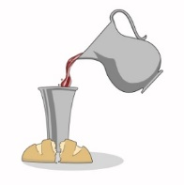
Sign and seal of being forgiven
Bread is ______________ and wine is _________________. It is ________________
_______. The _________________________is the ___________________________
Christ ________________________________________________________________
Thus we are ___________________________________________________________
__________________________________________________________________________________

Sign and seal of being renewed
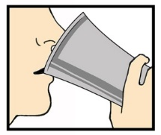
Food and drink ________________________________________________________
_____________________________________________________________________
We share _____________________________________________________________
And thus have _________________________________________________________
_____________________________________________________________________

Sign and Seal of being part of the Church
We celebrate ________________________________________________________________________
This expresses ______________________________________________________________________
___________________________________________________________________________________

Lord’s Supper as a sign
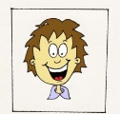
The Lord’s Supper makes clear to everyone:
_________________ ____________________ __________________________________
_________________ ____________________ __________________________________
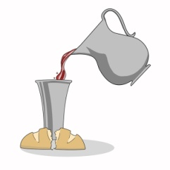
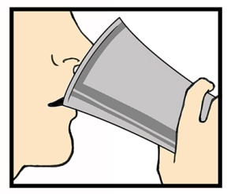
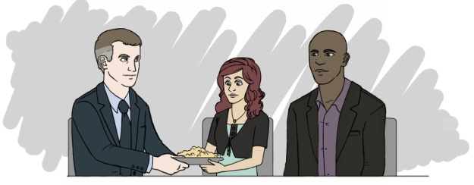
_________________ ____________________ __________________________________

Lord’s Supper as a seal
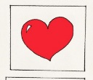
The person partaking of the Lord’s Supper may be certain of
_________________ _____________________ _________________________________
_________________ _____________________ _________________________________
_________________ _____________________ _________________________________

