Lesson 03: Election (2)
Confession Study: Canons of Dort I.1-7 (continuing on from last time)
1. Would God have done anyone an injustice if He had condemned all mankind ___________________
2. In what does God’s love become apparent (is God`s love made manifest)? _____________________
________________________________________________________________________________
3. Where and when does God have the message of the Gospel preached? ________________________
________________________________________________________________________________
4. What is the outcome of this preaching? _________________________________________________
________________________________________________________________________________
________________________________________________________________________________
5. Where lies the cause for unbelief? _____________________________________________________
6. Where lies the source of faith? ________________________________________________________
7. Where does the conferral of faith on some and not others proceed from? (I.e., how come God has
some people believe and others not? __________________________________________________
________________________________________________________________________________
8. Are all men equally worthy of condemnation, or are some better than others? ___________________
________________________________________________________________________________
9. What does God’s eternal decree of election do to holy and god-fearing souls? __________________
________________________________________________________________________________
10. How many people has God elected? __________________________________________________
11. Christ was appointed to be what? _____________________________________________________
12. What does our election through glorification demonstrate? ________________________________
13. What does our election through glorification praise? _____________________________________
14. What do you think, is our election unto salvation about us or about God? ____________________

God did not choose certain people because:
___________________________________________________________________________________
___________________________________________________________________________________
___________________________________________________________________________________
___________________________________________________________________________________
___________________________________________________________________________________
___________________________________________________________________________________

God chooses
___________________________________________________________________________________
___________________________________________________________________________________
___________________________________________________________________________________
___________________________________________________________________________________
___________________________________________________________________________________

The chosen
___________________________________________________________________________________
___________________________________________________________________________________
___________________________________________________________________________________
___________________________________________________________________________________
A person who chooses for God _________________________________________________________
___________________________________________________________________________________
___________________________________________________________________________________
A person who does not chose for God ____________________________________________________
___________________________________________________________________________________
___________________________________________________________________________________

Confession Study: Canons of Dort I.11-13
1. (11) Why is election unchangeable? ___________________________________________________
________________________________________________________________________________
2. (12) How do we not attain assurance of our election? ______________________________________
________________________________________________________________________________
3. (12) How do we attain assurance of our election? _________________________________________
________________________________________________________________________________
4. (13) Does the doctrine of election make Christians lax or give them false security? ____ because ___
________________________________________________________________________________
________________________________________________________________________________
________________________________________________________________________________
________________________________________________________________________________
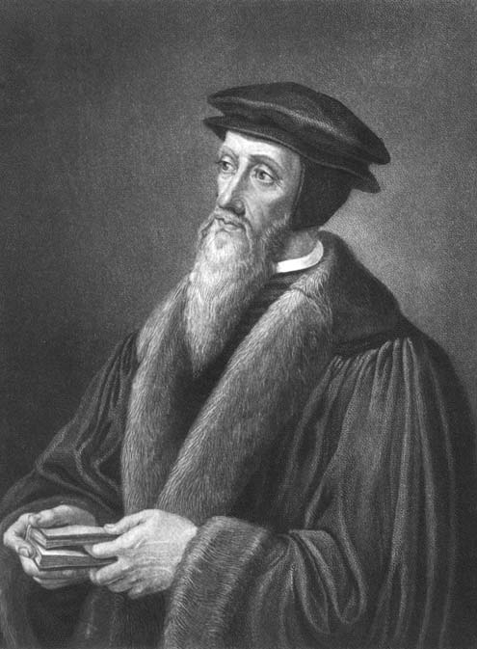

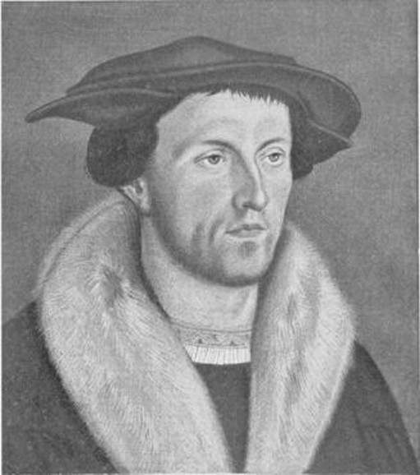
◄Heinrich Bullinger, often considered a
proponent of "double predestination"

John Calvin, instrumental in focusing►
attention on the doctrine of election

