Lesson 05 – Review 04

Memory Work

75. How does the Lord’s Supper signify and seal to you that you share in Christ’s one sacrifice on the cross and in all His gifts?
Christ has _______________________________________________________________
to use ________________________________________________________________
in _____________________________________________________________________
With this command He gave these promises:
First,
The _________________of the _______________________________ and
_________________ of the __________________________
Mean his ___________________ was ________________________ and
His ____________________ was ________________________________________________
for _______________________________of ________________________________________
Second,
The ____________________ of the ____________________________ and
_____________________of the ______________________
Mean his ___________and ____________________
___________________________________________________________________________
To live the ____________________________________________________________________

77. Where has Christ promised that He will nourish and refresh believers with His body and blood as surely as they of this broken bread and drink of this cup?
In _____________________________________________________________________________
As, for example, __________________________________________________________________

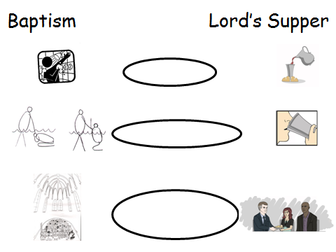
Review
1. (6) Place appropriate words in the three ellipses (bubbles) alongside. The words to choose from are “belonging”, “forgiveness” and “new life”
2. (4) How does the Lord’s Supper make clear to us how sins are forgiven?
____________________________________________
____________________________________________
____________________________________________
____________________________________________
____________________________________________
____________________________________________

