Lesson 05: Lord’s Supper – Who May Come?

Bible Study: 1 Corinthians 11:23-29
1. Where did Paul get his ideas from on the Lord’s Supper? ___________________________________
2. What is proclaimed whenever we eat the bread and drink from the cup? _______________________
________________________________________________________________________________
3. Who would be guilty concerning the body and blood of our Lord? ___________________________
________________________________________________________________________________
4. What should you do before participating in the Lord's Supper? ______________________________
5. What do you do if you do not properly recognize the body of the Lord? _______________________
________________________________________________________________________________

What is not necessary for a person to participate in the Lord´s Supper?
• A ______________________________________________________________________________
________________________________________________________________________________
• A ______________________________________________________________________________
________________________________________________________________________________
• An _____________________________________________________________________________
________________________________________________________________________________

What is necessary for a person to participate in the Lord´s Supper?
• ________________________________________________________________________________
________________________________________________________________________________
• ________________________________________________________________________________
________________________________________________________________________________
• ________________________________________________________________________________
________________________________________________________________________________
• ________________________________________________________________________________
________________________________________________________________________________

Who may not come?
Those who ______________________________________________________________________
________________________________________________________________________________
Those who ______________________________________________________________________
________________________________________________________________________________
________________________________________________________________________________
________________________________________________________________________________
The criterion for coming
The point is not _________________________________, how _____________________________
_________. You receive __________________, even if __________________________________!
The point is, _____________________________________________________________________
________________________________________________________________________________
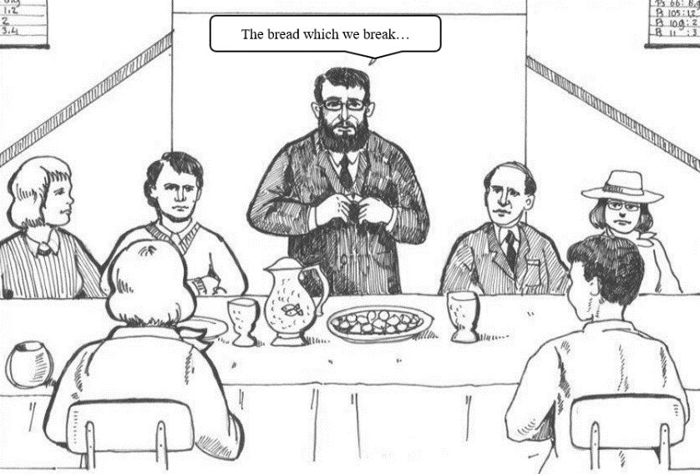
Do you ______________ your sins, or do you ____________them?

Sacraments and the covenant
Baptism is about the __________________ into the covenant
Baptism is only about _______________
_________________________________
_________________________________
_________________________________
Lord's Supper is about _________________ in the covenant.
Lord’s Supper is about ______________
________ and _______________________; thus we _____________________________________
Scripture explicitly requires _____________________________________ (1Corinthians 11:28-29)
The ability to examine oneself is thus _________________________________________________

You may come

____________________

____________________________

