Lesson 06: The First Key of the Kingdom - Preaching


Keys to God's Kingdom
_______________________________________________________________
_______________________________________________________________
_______________________________________________________________

Preaching is
_________________________
_________________________________
__________________________________
The message is, in brief:
________________________________________________________________________________
________________________________________________________________________________
________________________________________________________________________________
________________________________________________________________________________
________________________________________________________________________________

Bible Study: Acts 2:14-41
1. Who all stood up? ________________________
Who preached? ____________________________
2. Part one of the sermon (2:14b-21) is about ______________________________________________
3. Part two of the sermon (2:22-36) is about _______________________________________________
________________________________________________________________________________
________________________________________________________________________________
4. What was the reaction of the people? __________________________________________________
________________________________________________________________________________
5. What was the reaction of the preacher? _________________________________________________
________________________________________________________________________________
6. Explain how these words refer to both the opening and the closing of God’s Kingdom.
________________________________________________________________________________
________________________________________________________________________________
________________________________________________________________________________
7. To roughly how many people did this particular sermon open the Kingdom? _________________

The making of a sermon
- _____________________________________________________________________________
- _____________________________________________________________________________
- _____________________________________________________________________________
- _____________________________________________________________________________
- _____________________________________________________________________________
- _____________________________________________________________________________
- _____________________________________________________________________________
- _____________________________________________________________________________
- _____________________________________________________________________________
- _____________________________________________________________________________
- _____________________________________________________________________________

What do you remember of last Sunday morning's sermon?
________________________________________________________________________________
________________________________________________________________________________
________________________________________________________________________________
________________________________________________________________________________
________________________________________________________________________________
What can you add after listening to the class discussion?
________________________________________________________________________________
________________________________________________________________________________
________________________________________________________________________________
________________________________________________________________________________
________________________________________________________________________________
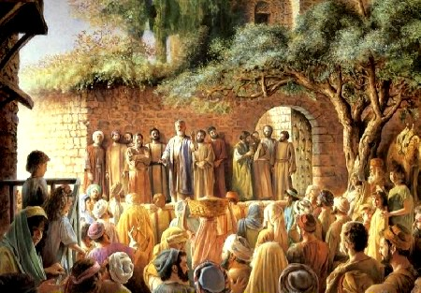
What do you think: is talking about the sermon later helpful? _______________________________

